CHAPTER I

INTRODUCTION

Mobile learning technologies and gamified educational applications have been shown to improve learner participation, motivation, and knowledge retention by promoting engaging and interactive learning experiences (Sailer & Homner, 2020; Alowayr & Al-Azawei, 2024). In the Philippines, these innovations present opportunities to enhance Arabic Language and Islamic Values Education (ALIVE), particularly for Filipino Muslim children who require learning resources that are age-appropriate, culturally relevant, and aligned with the current Department of Education (DepEd) elementary curriculum. However, many existing educational applications either lack localized content or are heavily dependent on stable internet connectivity.
To address these gaps, this study proposes SalamLearn: An Interactive Arabic Learning App for Filipino Muslim Children, as an offline-first Android mobile application that supports foundational Arabic language and Islamic values education (ALIVE) through interactive and gamified learning experiences. Designed for learners under the Level 1 curriculum, with integrated learning modules for students, child’s progress monitoring for parents, classroom support for teachers, and verification and creation for administrators. SalamLearn aims to support the teaching of Madrasah educators while promoting accessible, engaging, and curriculum-aligned learning experiences through home and school.

Project Context
Arabic and Islamic education plays a significant role in preserving the religious identity, cultural heritage, and moral development of Filipino Muslim children. Through the DepEd Arabic Language and Islamic Values Education (ALIVE) program, Muslim learners are provided with opportunities to develop foundational Arabic literacy and practice their understanding of Islamic teachings within the basic education system. Despite these efforts, many Madrasah institutions continue to experience challenges such as limited access to interactive learning resources, dependence on traditional teaching methods, and inconsistent internet connectivity, which may affect learner engagement and instructional delivery.
SalamLearn is proposed to address these challenges by providing a localized, interactive, and offline-first learning platform that supports both home and school learning environments. The application translates the curriculum-aligned Arabic language and Islamic values lessons into a gamified learning activities, whilst providing their child’s learning progress to parents, managing their classroom using integrated tools for teachers, administrator verification and creation of accounts for authorized educator access. Through these integrated features, SalamLearn aims to enhance learning accessibility, encourage collaboration among students, parents, teachers, and schools, while implementing ALIVE curriculum.

Project Description
SalamLearn: An Interactive Arabic Learning App for Filipino Muslim Children is an offline-first Android mobile application designed to provide an interactive and accessible learning environment for Filipino Muslim children in Grades 1 to 6. The application supports both independent home and school learning by combining interactive educational content, gamified learning experiences, learner progress monitoring, and classroom support within a single platform. It is intended to support traditional Madrasah instruction by providing learners, parents, teachers, and administrators with tools they need to support the Arabic language and Islamic values education that is aligned with the current DepEd ALIVE curriculum. These environments are driven by ten major system modules:
- Onboarding and System Initialization Module. Introduces first-time users to the application, prepares the device for use.
- Authentication and Profile Management Module. Manages account registration, authentication, and profile setting for students, parents, teachers, and administrators.
- The Student Hub (Child Interface). Provide students lessons, activities, achievements, and their overall learning progress.
- Core Educational Modules (ALIVE Curriculum). Delivers curriculum-aligned Arabic language and Islamic values lessons through interactive and gamified learning.
- Progress and Rewards System. Encourages learners through learning progress and awarding digital achievements.
- Parent Analytics Dashboard. Provides parents with visual summaries of their child's learning performance and progress.
- Teacher Learning Module. Assists teachers to facilitate classroom instruction, monitor learner progress, and manage learner activities.
- Administrator Module. Oversee teacher registration to ensure functions are only accessible to authorized personnel only.
- Offline-First Madrasah Classroom Mode. Allows interactive lessons to be delivered through a shared display without requiring internet connectivity.
- Settings and System Maintenance. Allows users to configure application preferences, manage stored data, and perform basic maintenance.

Project Objectives
The primary objective is to develop “SalamLearn: An Interactive Arabic Learning App for Filipino Muslim Children”. Specifically, the project aims to: Specifically, the project aims to:
- Design an interactive educational system consisting of the following integrated modules: Onboarding and System Initialization, Authentication and Profile Management, Student Hub, Core Educational, Progress and Rewards, Parent Analytics Dashboard, Teacher Learning, Administrator, Offline Classroom Package, and Settings and Maintenance Modules.
- Create the application using a modern, scalable and offline-first software architecture utilizing Flutter and Dart for front-end development, Firebase Cloud Services for backend development, and Hive NoSQL for database management.
- Test the application to verify its functionality, usability, compatibility, and reliability across supported Android devices.
- Evaluate the performance of the proposed system using ISO/IEC 25010 System and Software Quality Model in terms of Functional Suitability, Usability, Performance Efficiency, Security, and Reliability.
- Evaluate the effectiveness of SalamLearn by comparing learners’ pre-test and post-test performance.

Project Scope and Delimitation
The scope of this study covers the design and development of SalamLearn, an offline-first Android mobile application that supports the DepEd Arabic Language and Islamic Values Education (ALIVE) curriculum for Filipino Muslim learners in Grades 1 to 6 (ages 5–11). The application provides an interactive and gamified learning environment through the integrated modules. It supports both Home Mode, where parents facilitate their child’s learning at home, and Classroom Mode, where verified teachers manage classroom activities and monitor their student’s progress. SalamLearn is designed to encourage collaboration among students, parents, teachers, and administrators while ensuring being accessible through offline functionality alongside with the cloud synchronization when internet connectivity becomes available.
This study is limited to the Android platform and is intended solely as a supplementary educational tool that supports, rather than replaces, the teaching of qualified Madrasah educators. SalamLearn is confined only to the foundational Arabic language and Islamic values lessons aligned with the current DepEd ALIVE curriculum and does not cover advanced Arabic grammar, Qur'anic Tajweed, theological interpretation, or the issuance of religious rulings. SalamLearn is not designed to function similar to a Learning Management System (LMS), Student Information System (SIS), or a general classroom administration platform. Therefore, features such as attendance management, grading, messaging, curriculum authoring, document submission, and file sharing are beyond the scope of the project. Furthermore, all educational content included in the application shall be limited to materials reviewed and validated by designated Madrasah educators and content validators to ensure the accuracy and integrity of the learning materials.

Significance of the Project
The development of SalamLearn: An Interactive Arabic Learning App for Filipino Muslim Children is expected to benefit the following stakeholders:
For the Students. Children will gain an interactive and rewarding learning environment through Gamification modules.
For the Parents. Enables parents to actively monitor their children's learning progress and identify areas requiring additional practice.
For the Teachers (Asatidz). SalamLearn serves as a supplementary tool that assists teachers in facilitating lessons through interactive learning activities, classroom management features, learner progress monitoring, and offline classroom instruction.
For the Madrasah Institutions. Provides Madrasah institutions with a localized educational technology that supports the implementation of the DepEd ALIVE curriculum while promoting collaboration among students, parents, teachers, and school administrators.
For the Academe. The study contributes to educational technology by demonstrating the application of gamification, offline-first mobile learning, and learning analytics within Arabic language and Islamic values education.
For Future Researchers. This study establishes a foundational framework for applying gamification and tactile-recognition logic in localized, faith-based educational tools.

Project Timeline and Schedule of Activities
The project timeline for SalamLearn is divided into five phases, which will take place from conceptualization to institutional clearance. The phases are as follows:
Phase I: Methods of Research (January 2026 - May 2026). The end point is marked by the Title Proposal defense and the acceptance of the chosen Capstone Project adviser.
Phase II: Capstone Project 1 (June 2026 - July 2026). The main requirement is the initial documentation of the first three chapters. It will begin with the Proposal Defense.
Phase III: Capstone Project 2 (August 2026 - December 2026). The end point is marked by extensive system testing, user evaluation according to ISO 25010 standards, and final defense. .
Phase IV: Post-Defense Revisions and Submission (January 2027 - February 2027). The main requirements include manuscript submission for final grading and receiving a grade from the research course facilitator.
Phase V: Completion and Clearance (March 2027 - April 2027). The main requirement is the completion of all capstone project requirements.

Definition of Terms
ALIVE (Arabic Language and Islamic Values Education). Refers to the foundational syllabus and learning objectives that define the content structure of the SalamLearn application.
Asatidz. Refers to the qualified teachers who facilitate Arabic language and Islamic values education in Madrasah institutions.
Gamification. Refers to the use of progress badges, rewards, and drag-and-drop sorting games within the SalamLearn.
Madrasah. Refers to the specific learning environment or school where SalamLearn is deployed.
Talqeen. Refers to the traditional memorization that SalamLearn intends to supplement rather than replace, providing the digital "bridge" to move from passive listening to active interaction.
Telemetry Data. Refers to the collection of student performance metrics, such as tracing accuracy scores and module completion times, which are stored securely to populate the Parent Analytics Dashboard.
Whole Class Teaching (WCT). Refers to the "Offline Classroom Package" feature, which enables educators to cast interactive lessons from a single device to projectors or televisions to ensure collective participation in resource-constrained environments.

CHAPTER II

REVIEW OF RELATED LITERATURE

This chapter presents an overview of the literature relevant to the pedagogical and technical design of SalamLearn, a gamified mobile learning application for foundational Arabic and Islamic education. Digitally mediated learning is well embedded in most schools today, and many opportunities exist to optimize learning outcomes through digital interventions. However, introducing these technologies in a culturally specific and resource-limited context requires much sensitivity and localization. The theoretical foundation of this review connects the Technology Acceptance Model with the Cognitive Theory of Multimedia Learning. This is because, under such a theoretical umbrella, it can be argued that mobile learning technology will, to a significant extent, complement the normal flow of traditional religious classes and practices without violating any cultural norms and ensuring that the software application is accessible and usable by children.
The related literature is thus logically categorized into seven thematic areas, setting a technical and pedagogical foundation for SalamLearn. Theme 1 reviews human-computer interaction, cognitive profiles, and motor control associated with touchscreen-based learning applications for early learners (ages 5–11). Theme 2 addresses the learning of the Arabic language through the DepEd Arabic Language and Islamic Values Education Program, providing a contextual background to discuss the supportive need for interactive digital tools for traditionally memorized materials. Theme 3 introduces ethical limits in gamification and value formation, especially in the gamification of moral values. Theme 4 reviews pedagogical models for resource-constrained classrooms, covering Whole Class Teaching and offline-first software architectures. Theme 5 reviews learning analytics, active parental mediation, and the requirements of the Philippine Data Privacy Act of 2012 in collecting telemetry data of minors. Theme 6 introduces modern mobile architectures, including cross-platform frameworks and local databases. Lastly, Theme 7 defines usability and functional suitability metrics for child-targeted applications using the ISO/IEC 25010 standard.
Relevant local and international research is then reviewed in light of the thematic literature review to compare, contrast, and review specific methodologies and technical capabilities. The chapter then leads to the synthesis of the literature, which clearly specifies the research gap this study has addressed. The chapter ends with the theoretical and conceptual frameworks guiding the development of the proposed system.

Related Literature
Cognitive Profile and Digital Literacy of Early Learners (Ages 5-11)
Understanding how developmental psychology and human-computer interaction connect is extremely important when designing educational apps for young children. Early learners aged 5 to 11 possess distinct cognitive processing abilities and motor skills that dictate how they interact with touchscreen devices. While traditional classrooms rely heavily on static visual and auditory learning, Hatira and Sarac (2024) argued that tactile devices engage multiple sensory pathways simultaneously, providing haptic and kinesthetic feedback that improves knowledge retention over static instruction.
Empirical studies on childhood touchscreen gestures show clear age-based developmental milestones that should guide user interface design. Yadav and Chakraborty (2018) assessed touchscreen interactions across various age groups, demonstrating that while toddlers struggle with basic targeting, children aged 4 to 6 successfully perform simple single-finger gestures, such as tapping and sliding, with a 57% success rate. By ages 7 and 8, children graduate to more complex gestures, including dragging and dropping, showing a 30% success rate. Consequently, software designed for early learners should minimize text, avoid complex multi-finger shortcuts, and rely on intuitive, single-finger tactile interactions.
Soliman and Nathan-Roberts (2018) verified these limits by showing that writing or drawing on a screen requires significantly more cognitive resources than simple tapping, a capability that begins to develop reliably around age 5. Furthermore, passive screen time can harm motor development. Daud et al. (2020) discovered that intensive, passive touchscreen use correlates with deficits in fine motor precision and manual dexterity compared to non-users. However, these deficits are actively mitigated when the application intentionally requires guided, active tactile interactions.
This body of literature is highly relevant to SalamLearn because it justifies the design of the interactive character tracing module. By targeting the 5–10 age demographic, the application utilizes single-finger tracing paths and visual cues, which actively builds the child's fine motor coordination while simultaneously reinforcing visual symbol recognition.

Arabic Language Acquisition and Madrasah Curriculum Alignment
Islamic education in the Philippines is deeply rooted in the Madrasah system, which has historically served as the primary institution for preserving Islamic faith, Arabic literacy, and cultural heritage in Muslim-Filipino communities. The Department of Education formalized support for this system through DepEd Order No. 41, s. 2017, which established the Madrasah Education Program and set guidelines for the Arabic Language and Islamic Values Education (ALIVE) program within the K to 12 basic education curriculum, aiming to provide culturally relevant education that supports both linguistic proficiency and Islamic values formation for public school Muslim learners.
Despite this institutional framework, ALIVE classes face persistent structural and pedagogical challenges. Cortez (2026) explored the lived experiences of Muslim teachers (Asatidz) and found that they frequently encounter difficulties related to inadequate instructional materials, a lack of modern teaching aids, and the challenges of managing multi-grade classrooms. Ontok-Balah (2023) synthesizing ten ALIVE implementation studies conducted between 2015 and 2023 through a PRISMA-guided systematic review, confirmed that these resource and infrastructure gaps are a recurring, sector-wide concern rather than an isolated issue, while Salindab and Maglantay (2025) further found that teachers' educational background and length of service significantly predict learners' academic performance in the program. Mangadang et al. (2025) added that relying exclusively on talqeen (rote repetition and oral memorization) for foundational and entry-level learners causes cognitive fatigue and student disengagement because abstract language rules are taught without interactive or visual reinforcement.
To resolve these limitations, Idhan et al. (2026) found that Islamic school stakeholders in Indonesia perceived mobile apps as enhancing flexibility, engagement, and interactive learning for Arabic instruction, provided the technology is tailored to align with local pedagogical and religious values rather than imported wholesale. Kholifia et al. (2025) researched gamification in Arabic learning and proved that digital rewards and progress tracking reduce language anxiety and boost learner confidence. However, Hussain and Asif (2025) noted that educational apps must follow a structured, curriculum-aligned progression rather than presenting disjointed mini-games to be effective.
These findings directly justify SalamLearn’s structural alignment. By translating the standard DepEd ALIVE curriculum into interactive digital modules, the application functions as a supplementary teaching aid that respects Madrasah traditions while equipping educators with modern, engaging modalities.

Ethical Gamification and Values Formation in Islamic EdTech
Gamification is described as using game-design elements such as points, quest systems, and digital badges in non-game environments. It is shown to be an effective way to boost learner motivation. Azis et al. (2025) studied the impact of gamifying Islamic Religious Education, demonstrating that quest-based structures and digital badges increased active student participation to over 78% and elevated overall comprehension by up to 68%. Safitri et al. (2024) confirmed that digital gamification is highly effective for student motivation in religious studies, provided the mechanics do not conflict with religious teachings.
However, applying gamification to faith-based subjects requires strict adherence to ethical and theological boundaries. Zulkefli and bin Jamil (2024) examined the alignment of game-based learning with Islamic pedagogical principles and cautioned that mechanics borrowed uncritically from secular gamification models risk trivializing sacred material even when they succeed at boosting engagement; implementation must therefore be filtered through religious-pedagogical review rather than adopted wholesale. Attarwiyah et al. (2025), studying gamification in Islamic boarding schools, found that when school leadership deliberately drives the integration strategy, point systems, levels, and badges can increase student involvement and motivation while preserving, rather than displacing, the spiritual substance of instruction.
A critical application of this concept is gamifying moral classifications for young learners. Firdausia (2026) showed that active digital feedback loops during sorting and tracing tasks directly support constructivist learning, allowing young children to internalize complex ethical or jurisprudential rules through simplified, developmentally appropriate visual mechanics rather than abstract lecture. Mahazari and Hamzah (2026) added that digital tools should feature dual-mode architectures to ensure accessibility in low-infrastructure areas.
This literature directly justifies SalamLearn’s gamified logic. The app avoids addictive features and instead uses ethical gamification, like a Progress Rewards System with digital badges and a drag-and-drop sorting game to make abstract jurisprudential concepts accessible to early learners.

Pedagogical Models for Resource-Constrained Environments
A major barrier to educational technology in developing, rural, or minority communities is the digital divide. GlobeDock Academy (2023) explained that a severe "engagement gap" occurs in underfunded areas because of a lack of personal devices and reliable internet. Learning Equality (2026) argued that 1-to-1 device ratios are unfeasible in resource-constrained schools, meaning EdTech must leverage shared hardware.
Whole Class Teaching utilizing interactive projection and shared displays provides a highly effective solution to hardware scarcity. As researched by companies like EyeClick (2024) and BenQ (2026), interactive projection systems allow a single device to turn a traditional classroom into a collaborative learning environment, boosting attention span and improving test scores by up to 25%. Karthigesu et al. (2020) pointed out that projecting interactive activities enables shared group participation and bypasses the need for individual smartphones.
To survive in low-connectivity areas, applications must implement offline-first software architectures. Bansod et al. (2026) explained that offline-first principles require software to maintain full functionality without active cloud connections, accomplished by caching all critical multimedia assets, audio pronunciations, and curriculum guides directly onto the host device. Umar and Argungu (2025) validated this approach empirically, finding that an offline-first mobile learning app using local caching and pre-downloaded content modules produced significant improvements in learner engagement and knowledge retention compared to online-dependent platforms. Mays and Cheng (2024) similarly found that offline-first platforms sustain continuity of learning in remote primary schools where bandwidth is scarce or unavailable, though they note that rigorous evidence at the primary level specifically remains limited in the literature. Learning Equality (2026) and GlobeDock Academy (2023) further demonstrated that offline-first educational systems achieve high scalability and sustainability in underserved, historically marginalized areas, a finding echoed by Aguilera et al. (2026) in their evaluation of an offline AI-literacy application with 96 rural, multigrade teachers in Chile, who rated the tool's offline architecture as directly responsive to classroom heterogeneity. Samudio (2022) noted that developers must balance robust offline data caching with interactive UI designs, while Samala et al. (2026) confirmed through formative usability testing that offline-first design functions as a strategic paradigm for equitable access rather than a mere technical workaround.
These models form the technical core of SalamLearn. The app features an "Offline Classroom Package" that allows educators to project lessons on a single shared screen, bypassing device scarcity and ensuring uninterrupted learning without an active internet connection.

Learning Analytics, Parental Mediation, and Data Privacy
Deploying mobile applications that collect user telemetry requires a strict approach to data security, especially when dealing with minors. In the Philippines, the Data Privacy Act of 2012 (Republic Act No. 10173) mandates legally binding guidelines for processing personal information. Under Section 3(1) of RA 10173, student academic records, progress logs, and tracking metrics are classified as sensitive personal information. Educational technology developers act as Personal Information Controllers and must enforce data transparency, limit collection, and secure explicit parental consent. Dela Rosa (2025) and Doce (2018) warned that educational software must integrate privacy by design, avoiding third-party advertising trackers and securing local data storage.
Beyond legal compliance, capturing student progress logs feeds into learning analytics, which serves as a powerful diagnostic tool when paired with active parental mediation. Goodall and Flewitt (2025) analyzed digital parenting styles, distinguishing between restrictive mediation (limiting screen access with rigid rules) and active mediation (collaborating with the child to guide learning). Nagy et al. (2023), drawing on a representative survey of 1,000 Hungarian families, similarly identified balancing, restrictive, permissive, and ad hoc mediation as the primary parental strategies, finding that parental mediation performance correlated significantly with both children's screen time and the subjective quality of parenting. While restrictive mediation can lead to digital procrastination and limit autonomy, active mediation improves cognitive outcomes. Ma and Li (2026) verified that rigid, restrictive locks fail to correct mobile usage habits, making active guidance the preferred strategy.
To support active mediation, mobile apps must provide parental analytics dashboards. These dashboards translate raw telemetry, such as tracing accuracy, module completion times, and jurisprudence sorting scores into visual charts. This data-driven transparency allows parents to monitor learning progress asynchronously. Armed with these logs, parents can offer targeted praise and identify unique learning difficulties, actively participating in their child's education without compromising the child's data privacy rights.
This justifies the design of SalamLearn’s data systems. The app complies with RA 10173 by localizing student progress data and securing parental consent, while its Parent Analytics Dashboard equips caregivers with visual progress logs to support active home mediation.

Evaluating Mobile Architectures in EdTech
The technical architecture of a mobile application directly determines its performance, frame rates, and longevity on older devices. For community-oriented projects targeting varied hardware, cross-platform mobile frameworks are essential. Panda (2025) compared cross-platform options and highlighted Google's Flutter framework as a dominant tool because of its single-codebase development model using Dart.
Unlike older cross-platform frameworks like React Native, which communicate asynchronously with native hardware components via a JavaScript bridge, Flutter compiles Dart code Ahead-of-Time directly into native ARM machine code. Panda (2025) documented that bypassing the JavaScript bridge in this way eliminates rendering lag and gives Flutter superior UI flexibility and faster, near-native response times compared to React Native. For child-centric apps requiring real-time tracing modules and physics-based sorting animations, this performance advantage is critical to a smooth learning experience.
For local data persistence, Hive presents a lightweight NoSQL key-value store built specifically for Dart. Relational databases are highly effective for complex, multi-table queries, but Hive is optimized for rapid read/write operations and has no native dependencies. Ochoa and España (2026) and Zohud and Zein (2021) validated that the Flutter and Firebase stack provides high usability and reduces development cycles.
This stack directly supports SalamLearn’s offline-first performance. By building the front-end with Flutter, the app renders fluid character tracing animations, while its hybrid database architecture uses Hive for instant local caching and Firebase for secure parental sync.

Software Quality Standards (ISO/IEC 25010)
To ensure that an educational application meets its pedagogical goals and runs reliably on target devices, developers must evaluate it against established international standards. The ISO/IEC 25010 standard defines a quality framework composed of eight characteristics, with Usability and Functional Suitability being paramount for foundational and entry-level software.
Functional suitability evaluates whether the application provides accurate, complete, and appropriate features for its goals. For SalamLearn, this ensures that Arabic characters are drawn, traced, and pronounced accurately according to curriculum guidelines, and that gamified rules correctly teach such concepts.
Usability (revised as interaction capability in the 2023 standard update) measures how effectively and satisfyingly a user can operate the software. Jung et al. (2025) analyzed foundational and entry-level app feedback and mapped user concerns directly to ISO/IEC 25010. Their analysis showed that usability, functional suitability, and compatibility represent parents' primary concerns regarding educational reliability and ease of use. Januhari et al. (2025), applying the ISO/IEC 25010 Quality-in-Use model to e-learning systems in Indonesia, similarly found that usability exerted a significant direct effect on user satisfaction, with efficiency emerging as the most influential sub-factor, though cultural context meaningfully moderated this relationship, underscoring that usability evaluation cannot be separated from the cultural specificity of the end-user population. Evaluating usability with children aged 5 to 10 requires objective testing methods. Carrión-León et al. (2025) proved that traditional self-reported surveys fail when used with young children. Instead, researchers must capture objective gameplay telemetry, capturing touch coordinates, time-on-task, and error recovery rates to accurately measure usability. Finally, Nugroho and Fx (2025) noted that software architectures must prioritize maintainability, ensuring that codebases are structured for easy modifications when adding advanced Madrasah modules.
This guides SalamLearn's evaluation methodology. The app will be assessed by IT experts and educators using ISO/IEC 25010 usability metrics, and user testing with children will rely on objective gameplay telemetry rather than complex surveys.

Related Studies
The review of related studies contextualizes the proposed project within the existing body of empirical research, identifying how previous developers, educators, and academicians have tackled similar educational and technological challenges both locally and internationally. This comparative analysis serves to highlight established best practices while simultaneously exposing the functional limitations that the present study intends to resolve.

Local Studies
In the Philippines, several completed studies have explored the practical and pedagogical aspects of the DepEd ALIVE program, as well as the implementation of offline educational technology in rural settings. Mangadang et al. (2025) conducted a descriptive study to assess the implementation of the ALIVE program in public elementary schools across Mindanao. Their findings revealed that public schools struggle with a severe lack of localized visual media and short instructional periods, which limits Arabic vocabulary retention among young learners. This study is highly relevant because both projects align with the ALIVE curriculum to improve Arabic literacy, but Mangadang et al. (2025) focused on program assessment, whereas SalamLearn serves as a practical software intervention.
Cortez (2026) conducted a qualitative phenomenological study exploring the lived experiences of Asatidz teaching ALIVE in public schools. The study found that teachers face difficulties due to multi-grade classrooms, inadequate instructional aids, and a lack of technological support. This qualitative research aligns with the current study's focus on the public school classroom environment, but Cortez (2026) focused on documenting teaching experiences, while SalamLearn provides an "Offline Classroom Package" to directly support these educators.
Addressing technical limitations in rural schools, Bansod et al. (2026) developed and evaluated an offline-first examination and data management system for rural school societies. Utilizing an agile development methodology, the researchers demonstrated that local database persistence and reactive frontend caching maintain high operational efficiency in low-connectivity areas. Both systems use offline-first databases to bypass poor internet connectivity, but Bansod et al. (2026) focused on administrative examination data, whereas SalamLearn targets early childhood gamification and character tracing.
Dela Rosa (2025) and Doce (2018) conducted quantitative evaluations of state university compliance with the Data Privacy Act of 2012 (RA 10173). Their audits showed that educational information systems frequently compromise student data because of technical constraints and a lack of privacy-by-design training. While these studies emphasize the critical need for data protection, they analyzed administrative university portals, whereas SalamLearn is a mobile application designed specifically to secure the telemetry data of minors.
Mina (2021) evaluated a local online enrollment system using the ISO/IEC 25010 quality framework. Using survey evaluations, the research showed that while the system scored high in functional completeness, it struggled with performance efficiency because of local bandwidth bottlenecks. Both studies evaluate educational software using international ISO quality standards, but Mina (2021) evaluated an online enrollment platform, while SalamLearn relies on local Hive caching to bypass bandwidth limits entirely.
Abrenica (2021) conducted a qualitative case study on the academic challenges faced by Muslim learners in public high schools. The research showed that minority students face academic anxiety and strongly desire culturally specific curriculum integration to support their religious identity. Both projects recognize the need to support Muslim student identities, but Abrenica (2021) analyzed qualitative high school student perspectives, whereas SalamLearn is a mobile tool designed for foundational childhood literacy.
Extending this local body of evidence, Salindab and Maglantay (2025) conducted a descriptive-correlational study examining ALIVE implementation, teacher pedagogical practices, and learner performance within the DepEd Division of Sultan Kudarat. Using survey questionnaires analyzed through correlational statistics, they found that teachers' educational background and length of service significantly predicted learner academic performance, while gender and licensure eligibility did not. This study reinforces the connection between instructional quality and ALIVE learner outcomes that SalamLearn's teacher-support features are designed to strengthen; however, Salindab and Maglantay (2025) examined a policy- and teacher-centered angle, whereas SalamLearn is a direct learner-facing intervention.
Baling (2026) developed and pilot-tested a localized mobile application integrating local history into the teaching of Araling Panlipunan 7 using the ADDIE Model, validated by thirteen subject experts and piloted with a cohort of Grade 7 learners across two school years, ultimately producing a statistically significant pretest-posttest improvement. Both projects follow a comparable design-validate-pilot pathway for a curriculum-localized mobile application; however, Baling (2026) targeted secondary-level social studies content, while SalamLearn targets foundational Arabic literacy and Islamic values for children aged 5–10.
Pedraza and Canoy (2025) conducted a quantitative descriptive-comparative study assessing the effectiveness of mobile learning apps among 60 secondary public-school students in General Trias City, Cavite, finding that mobile apps were rated strongly effective in enhancing learning and, notably, in boosting engagement through gamification and diverse content. This study is highly relevant given its shared provincial context with the present study, but Pedraza and Canoy (2025) evaluated generic, already-available commercial mobile learning apps among secondary students, whereas SalamLearn is a purpose-built application for foundational-level Filipino Muslim learners.

Foreign Studies
Internationally, the digitization and gamification of Arabic language acquisition and Islamic studies have progressed rapidly, providing functional blueprints. Al Hejaili and Newbury (2023) developed and evaluated LAA: Learn the Arabic Alphabet, a touchscreen mobile application. Using user experience testing with young cohorts, they demonstrated that gamified on-screen character tracing and visual-auditory matching improve letter recognition. This is similar since it serves as the direct inspiration for SalamLearn’s tactile tracing module. However, their app was a single-learner tool, while SalamLearn includes an offline classroom casting mode and broader Islamic jurisprudence games.
Kholifia et al. (2025) evaluated gamified Arabic speaking tools for language anxiety. Using a quasi-experimental method, they discovered that interactive progress rewards and digital badges lower student anxiety and improve engagement. Both use gamified mechanics to encourage language acquisition. However, Kholifia et al. (2025) focused on oral speaking skills for older learners, while SalamLearn targets basic writing and spelling for children aged 5–10.
Azis et al. (2025) investigated gamified Islamic Religious Education (PAI) in Indonesia. Using a quasi-experimental research design, the study showed that quest structures and points raised student interest and improved comprehension by 68. Both projects gamify religious values. However, Azis et al. (2025) conducted her study in an Indonesian curriculum context requiring 1-to-1 personal tablets, whereas SalamLearn is built for the Philippine ALIVE framework and supports a 1-to-many classroom projection model.
Idhan et al. (2026) investigated the perspectives of Islamic school stakeholders, including teachers, students, administrators, and parents, on the use of mobile apps for Arabic language teaching in Palu, Indonesia, using the Mobile-Assisted Language Learning framework and the Technology Acceptance Model. They found that while mobile apps enhanced flexibility and engagement, infrastructural limitations, teacher readiness, and cultural attitudes remained persistent barriers, and that technological solutions must be tailored to align with pedagogical and religious values. Both studies address mobile-assisted Arabic instruction within an Islamic educational context; however, Idhan et al. (2026) focused on stakeholder perceptions of existing general-purpose apps, while SalamLearn is a purpose-built, curriculum-integrated application.
Nagy et al. (2023) surveyed 1,000 Hungarian families to examine the relationship between adolescents' screen time, learning outcomes, and parental mediation strategies, identifying balancing, restrictive, permissive, and ad hoc mediation as the dominant approaches and finding that parental mediation performance correlated significantly with perceived parenting quality. Both studies recognize active parental involvement as central to healthy technology use in children; however, Nagy et al. (2023) examined general adolescent mobile device use in a Western context, while SalamLearn targets younger Filipino Muslim children within a structured religious-education application.
Januhari et al. (2025) evaluated e-learning usability among 384 university students in Bali using the ISO/IEC 25010 Quality-in-Use framework moderated by Hofstede's cultural dimensions, finding that usability significantly predicted user satisfaction and that cultural factors, particularly individualism-collectivism, meaningfully moderated this relationship. Both studies apply the ISO/IEC 25010 standard to evaluate educational software usability; however, Januhari et al. (2025) studied university-level e-learning platforms in a general cultural context, while SalamLearn applies the standard to a child-centric, culturally specific Filipino Muslim application.
Aguilera et al. (2026) designed and evaluated a purpose-built offline mobile application for teaching AI literacy to multigrade rural classrooms in Los Lagos, Chile, through participatory workshops with 96 teachers, achieving a "good" System Usability Scale score and confirming that the offline architecture was perceived as directly responsive to classroom heterogeneity. Both projects target offline-first, multigrade, resource-constrained classroom contexts; however, Aguilera et al. (2026) evaluated teacher-mediated AI literacy content, while SalamLearn targets learner-facing Arabic literacy and Islamic values content.
Mays and Cheng (2024) examined the effectiveness of offline e-learning models in remote primary schools through a mixed-methods case study, finding that offline-first platforms sustained learning continuity despite bandwidth scarcity, though they noted that primary-level evidence specifically remains limited in the literature. Both studies address the underexplored intersection of offline-first design and primary-level education; however, Mays and Cheng (2024) examined general curriculum content delivery, while SalamLearn is specifically a gamified Arabic and Islamic values application.
Umar and Argungu (2025) developed and evaluated an offline-capable mobile learning application using local caching and pre-downloaded content modules, employing user surveys, field testing, and performance evaluation, and found significant improvements in learner engagement and knowledge retention compared to online-dependent platforms. Both applications rely on local caching as their core offline strategy; however, Umar and Argungu (2025) evaluated a general-purpose offline learning tool, while SalamLearn integrates this architecture specifically with gamified Arabic tracing and Islamic jurisprudence content.
Finally, Samala et al. (2026) designed and formatively evaluated an offline-first collaborative digital logbook application for service-learning programs across Indonesia and Timor-Leste, achieving a "Good" System Usability Scale score and concluding that offline-first architecture functions as a strategic paradigm for equitable digital transformation rather than a mere technical workaround. Both studies position offline-first design as a deliberate equity strategy rather than a fallback feature; however, Samala et al. (2026) evaluated an administrative documentation tool for higher education, while SalamLearn is a gamified literacy tool for foundational-level Filipino Muslim children.

Synthesis
The reviewed literature and related studies consistently highlight the benefits of gamification, tactile human-computer interaction, and mobile learning in foundational and entry-level education. Foreign studies have shown that gamifying Arabic character-tracing and Islamic jurisprudence reduces cognitive load, lowers language anxiety, and improves long-term memory. At the same time, local studies highlight the persistent challenges in the Philippine Madrasah and ALIVE systems, where teachers struggle with a lack of resources, multi-grade classrooms, and poor internet access.
However, existing foreign educational applications are built for Middle Eastern or Indonesian classrooms and require 1-to-1 student device access with continuous internet connectivity, making them unusable in underfunded public schools. Conversely, local software solutions focus primarily on administrative features and lack interactive, culturally appropriate gamified content designed specifically for Filipino Muslim children.
This exposes a specific research gap: there is currently no localized, high-performance, cross-platform mobile application designed specifically for the Filipino Muslim child (ages 5–11) that integrates tactile Arabic tracing and subject gamification while simultaneously functioning as an offline-first, Whole Class Teaching (WCT) casting tool for resource-constrained Madrasahs, all while maintaining strict compliance with the Philippine Data Privacy Act (RA 10173) for the telemetry data of minors. SalamLearn directly addresses this gap. It utilizes Flutter and Hive to build an offline-first mobile app that features a progress dashboard for active parental mediation and an offline projection mode for teachers, permanently bridging the digital divide in Filipino Madrasah education.

Theoretical Framework
This study is anchored on two primary theories: the Technology Acceptance Model (TAM) proposed by Fred Davis (1989), and the Cognitive Theory of Multimedia Learning developed by Richard Mayer (2001). Together, these theories explain why users will adopt the proposed software and how children will process its educational content.
Figure 1
Technology Acceptance Model
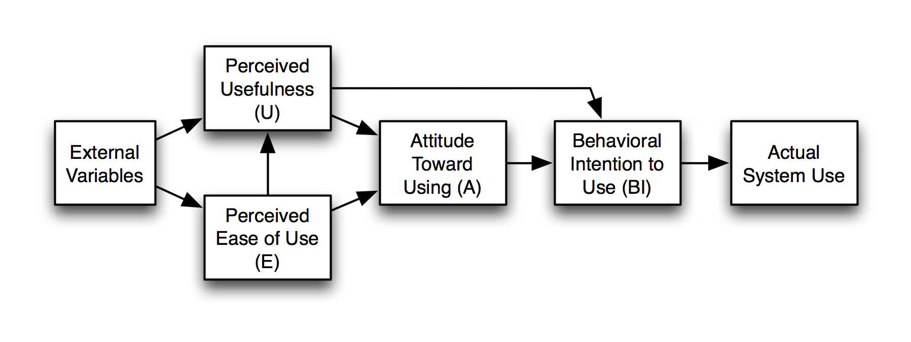

The Technology Acceptance Model states that technology adoption is driven by Perceived Usefulness (PU) and Perceived Ease of Use (PEOU). For SalamLearn, Perceived Usefulness directly affects teachers and parents. For Asatidz, usefulness is established because the app provides an Offline Classroom Package, allowing teachers to cast interactive group lessons and bypass hardware scarcity. For parents, usefulness is demonstrated by the analytics dashboard, which allows them to track progress and practice active mediation. Perceived Ease of Use centers on the application's interface design. To be accepted, the child's interface must use single-finger gestures, avoid complex multi-finger shortcuts, and utilize intuitive visual-first navigation to accommodate early learners with developing cognitive abilities.
Figure 2
Mayer’s Cognitive Theory of Multimedia Learning
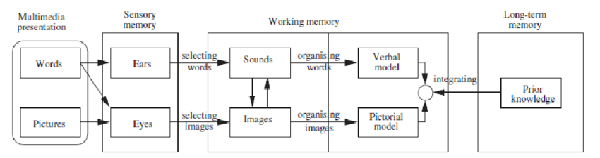

Mayer's Cognitive Theory of Multimedia Learning supports TAM by explaining how young children process digital information. The theory states that the human brain processes visual and auditory information through separate cognitive channels, and that learning is optimized when both channels are stimulated simultaneously without overloading working memory. SalamLearn applies this theory through its multi-sensory modules: combining interactive path-tracing (kinesthetic), colorful character graphics (visual), and authentic audio pronunciations (auditory). Designing the app around these dual channels prevents cognitive fatigue while maximizing retention, ensuring that the interface is developmentally appropriate and pedagogically sound under ISO/IEC 25010 standards.

Conceptual Framework
The conceptual framework of this study is structured around the Input-Process-Output (IPO) model. This framework maps the inputs, agile processes, and system outputs required to build a validated educational technology solution for Filipino Madrasah environments.
Figure 3
Input-Process-Output Model of SalamLearn
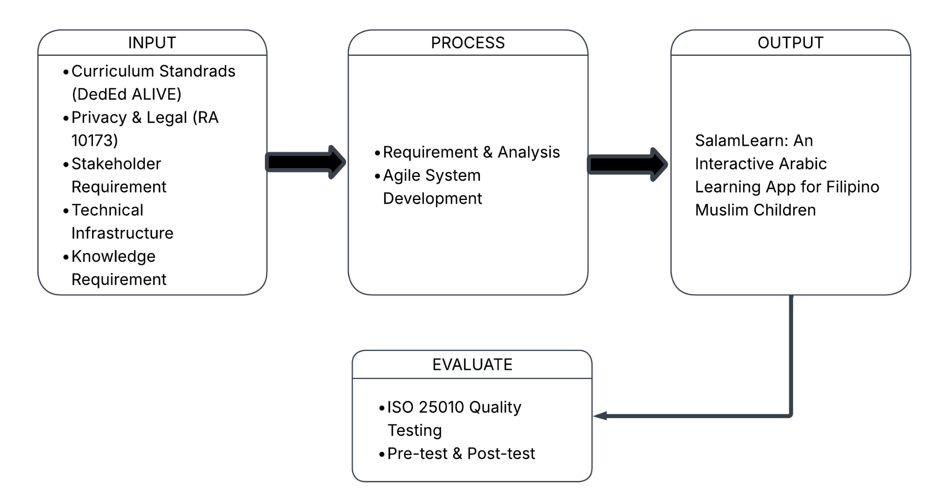

The Input consists of the pedagogical guidelines from the Refined Elementary Madrasah Curriculum (DepEd ALIVE), legal compliance mandates under the Data Privacy Act of 2012 (RA 10173), user requirements gathered from Muslim parents and public school Asatidz, and the hardware and software requirements necessary for system development. These inputs provide the necessary information, resources, and requirements needed to address the structural and technological barriers in traditional Madrasah environments and begin the development of the proposed system.
These inputs undergo a series of Processes including requirements elicitation, system analysis, user interface prototyping, and continuous mobile development using the Agile Software Development Methodology. Following the development phase, the process also involves rigorous testing based on ISO/IEC 25010 Software Quality Standards and a comprehensive system evaluation conducted by early learners, parents, and Asatidz to validate its pedagogical effectiveness. These activities transform the identified inputs into a functional and validated solution that addresses the needs of the intended users.
The Output of the study is the development and implementation of SalamLearn: An Interactive Arabic Learning App for Filipino Muslim Children. The resulting system is a fully functional, offline-first mobile application expected to provide interactive Arabic tactile tracing, gamified learning modules, an offline classroom toolkit, and a secure parent analytics dashboard, thereby addressing the lack of localized digital supplementary materials identified during the preliminary investigation.

CHAPTER III
METHODOLOGY
Research Design
The study employed a developmental-descriptive research design to guide the design, development, and evaluation of SalamLearn: An Interactive Arabic Learning Application for Filipino Muslim Children. The developmental research design was utilized to systematically analyze user requirements, design the system architecture, develop the mobile application, and integrate its educational modules based on the needs of Muslims learners, parents, and Madrasah educators.
The descriptive research design was used to evaluate the completed application. The software quality and user acceptability of SalamLearn were assessed by Madrasah teachers and parents using ISO/IEC 25010 Software Quality Model, while the educational effectiveness of the application was determined through a pre-test and post-test administered to selected Grade 1 to Grade 3 Muslim learners. Additionally, the application’s instructional content underwent validation by a qualified Ustadh to ensure that the learning materials were accurate, culturally appropriate, and aligned with Islamic teachings. This combined research design ensured that SalamLearn met both its technical objectives and educational goals.

Software Development Methodology
This study uses the Agile Software Development Methodology due to its iterative and incremental approach, which enabled the development team to continuously refine SalamLearn based on stakeholder feedback throughout the development process. Agile was considered suitable for the project because the application required frequent revisions to its educational content, user interface, and system functionalities while ensuring that the needs of students, parents, and Madrasah teachers were consistently addressed.
The Agile methodology being implemented in this study consisted of the following phases: requirements gathering, where initial data was collected at Sultan Esmael to establish the foundational needs of the users, followed by system analysis and design, where the gathered data will be carefully analyzed to align the application's design with the identified requirements. Following this, the application development will be highly iterative based on continuous testing. Upon validation of the educational contents, the researchers will make necessary revisions based on stakeholder evaluation, after which the updated system will be used for another round of testing before succeeding to the deployment phase. This approach enabled the researchers to identify issues early, implement necessary enhancements, and ensure that the final version of SalamLearn was reliable, user-centered, and aligned with the objectives of the study.

Figure 4
AGILE Model
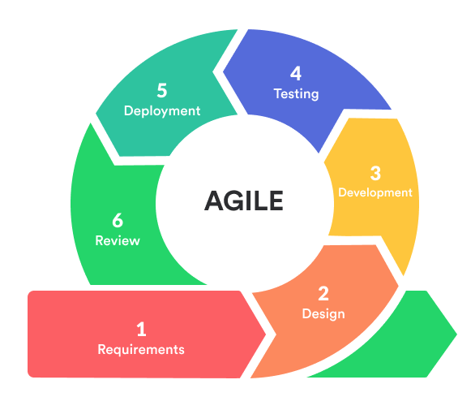
Participants of the Study
The participants of this study consisted of Madrasah teachers, parents, and selected Grade 1 to Grade 3 Muslim learners from Villa Apolonia Elementary School. The participants were selected through purposive sampling, as SalamLearn was specifically developed for Level 1 Madrasah learners and their learning facilitators. Based on the device availability survey conducted by the researchers, 42 out of 54 respondents had access to an Android device suitable for running the application. Among them, 15 learners owned a personal device, 29 used their parents' devices, and 2 shared a device within the household. These participants were included in the implementation and evaluation of the system. Madrasah teachers and parents will be evaluating SalamLearn using an ISO/IEC 25010-based evaluation questionnaire, while the selected learners will participate in the pre-test and post-test to measure the application's effectiveness in improving foundational Arabic and Islamic learning.

Research Locale
The study is currently being conducted at Villa Apolonia Elementary School, located in Barangay Ibayo Silangan, City of Naic, Cavite, under the Schools Division Office of Cavite, Department of Education Region IV-A (CALABARZON). The school was selected because it offers the Madrasah Education Program and serves the target users of SalamLearn. It also provided an appropriate setting for conducting the requirements gathering, system implementation, and evaluation activities. The study was limited to the Madrasah program of the school, involving selected Muslim learners, parents, and Madrasah teachers. The results of the device availability survey also guided the development of SalamLearn's offline-first functionality to accommodate users with limited internet connectivity.

Data Gathering Procedure
Data gathering proceeded in the following steps. First, a letter of request was sent to the school's administration to secure permission to conduct the study at Datu Esmael Elementary School. Second, a device availability survey was conducted to determine the accessibility of Android devices among the target users. Third, will be the content validation of SalamLearn which will be reviewed by qualified Ustadhs to verify the accuracy of the Arabic lessons, Islamic concepts, and learning activities. Fourth, there will be a pre-test to assess their existing knowledge of the lesson topics, then they will use SalamLearn during the implementation period under the guidance of their parents and Madrasah teachers. After the completion of the implementation period, there will be a post-test to measure if there is learning improvement. Finally, Madrasah teachers and parents will evaluate SalamLearn using an evaluation questionnaire based on the ISO/IEC 25010 Software Quality Model. After completing the questionnaires, they will be collected, organized, and prepared for statistical analysis to determine the overall acceptability of SalamLearn.

Research Instrument
For system testing and improvement, the researchers will utilize functional, usability, and compatibility test instruments to verify whether the developed features of SalamLearn perform according to the identified requirements. These instruments will be reviewed and validated by the research adviser and IT experts to ensure their accuracy and relevance before system testing. For requirements gathering, the researchers will use a semi-structured interview guide, observation checklist, document review, and device availability survey to identify the learning needs, existing practices, and technological limitations of the target users. These instruments will support the analysis and design of the proposed application. For content validation, the learning materials, Arabic lessons, Islamic concepts, pronunciation activities, and interactive modules of SalamLearn will be reviewed by a qualified Ustadh to ensure that the application's content is accurate, appropriate, and aligned with Islamic teachings.
For system evaluation, the study will employ a structured Software Product Quality Questionnaire adapted from the ISO/IEC 25010 Software Quality Model. The questionnaire will evaluate the application based on the following quality characteristics: Functional Suitability, Performance Efficiency, Compatibility, Usability, Reliability, Security, Maintainability, and Portability. Responses will be scored using a 4-point Likert Scale structured as follows: 4 (Highly Acceptable), 3 (Fairly Acceptable), 2 (Acceptable), 1 (Unacceptable). The evaluation questionnaire will be verified by the research adviser to ensure that the items are clear before administering to the participants.
Furthermore, to measure the educational effectiveness of SalamLearn on student performance, a comparative analysis will be conducted between two distinct classes: an experimental group utilizing the application and a control group taught via traditional methods. To facilitate this assessment, a pre-test and post-test will be administered to the learners. Prior to implementation, these evaluation instruments will undergo expert validation to ensure content appropriateness. Additionally, the reliability of the test instruments will be statistically established using Cronbach’s Alpha to ensure high internal consistency and accuracy in measuring the learners' foundational knowledge.

Statistical Treatment of Data
Quantitative data that will be gathered from the ISO/IEC 25010 software evaluation questionnaires answered by Madrasah teachers and parents will be analyzed using descriptive statistics, specifically frequency distribution, percentage, and weighted mean. The weight mean will be calculated using the formula:
$x̄ =Σ (f . x) / N$
where x̄ is the weighted mean, f is the frequency of responses for each option, x is the weight assigned to each 4-point Likert scale option, and N is the total number of respondents.
To interpret the overall quality evaluation results of SalamLearn, the following statistical scale boundaries were applied:
Table 1
4-Point Likert Scale Range and Interpretation

To determine the educational effectiveness of SalamLearn, the study will utilize a two-group pre-test and post-test comparative analysis involving selected Grade 1 to Grade 3 learners. The learners will be divided into an Experimental Group (using SalamLearn) and a Control Group (using traditional learning methods). The following inferential statistical tools will be used, tested at a 0.05 level of significance (α = 0.05):

1. Paired Samples t-test: This will be used to determine if there is a significant difference between the pre-test and post-test scores within each respective group. This measures the internal knowledge improvement of the learners before and after the intervention. The formula is expressed as:

t = d̄ / (s_d / √n)
Where:
- d̄ = mean of the differences between paired observations (post-test – pre-test)
- s_d = standard deviation of the differences
- n = sample size
2. Independent Samples t-test: To conduct the comparative analysis between the two classes, the Independent Samples t-test will be applied to the mean gain scores (the difference between post-test and pre-test) of the Experimental Group and the Control Group. This will determine if the application of the SalamLearn system yielded a statistically significant advantage in foundational Arabic literacy and Islamic values knowledge compared to the traditional teaching method. The formula is expressed as:
t = (x̄₁ - x̄₂) / √ [ (s₁² / n₁) + (s₂² / n₂)
Where:
- x̄₁, x̄₂ = the mean gain scores of the Experimental and Control groups, respectively
- s₁², s₂² = the variances of the Experimental and Control groups
- n₁, n₂ = the sample sizes of the Experimental and Control groups
System / Network Architecture and Design
SalamLearn follows a client-server architecture with an offline-first approach, where the mobile application serves as the client interface while Firebase provides cloud-based services for authentication, database management, and storage. The architecture consists of four primary components: the mobile application layer, local storage layer, cloud service layer, and user management layer. The mobile application is under development using Flutter providing learning modules, gamification features, progress monitoring, and user dashboards. Hive local storage enables offline access by temporarily storing learning data, while Firebase services support authentication, cloud data synchronization, and multimedia storage.

System Flowchart
Standard flowchart symbols are used throughout: an oval for Start/End, a rectangle for a process step, and a diamond for a decision point with clearly labeled Yes/No paths. as you can see on the figure 5 below, it shows how SalamLearn will operate every time opening the app. The process starts by having the required resources initialized up to the acceptance of the privacy policy. Then proceeded to User Selection where they can choose how they will operate the app.
Figure 5
Setup of SalamLearn flowchart
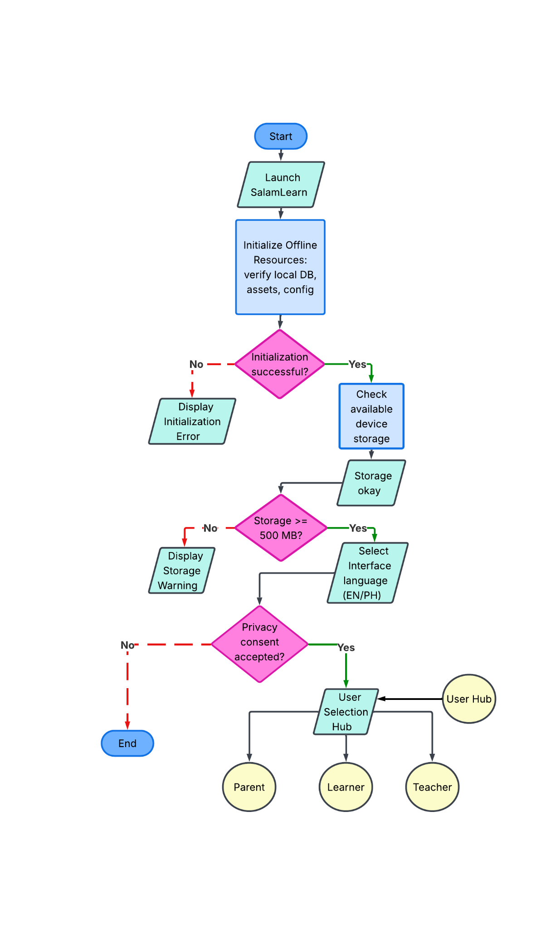

Figure 6
SalamLearn Learner Flowchart
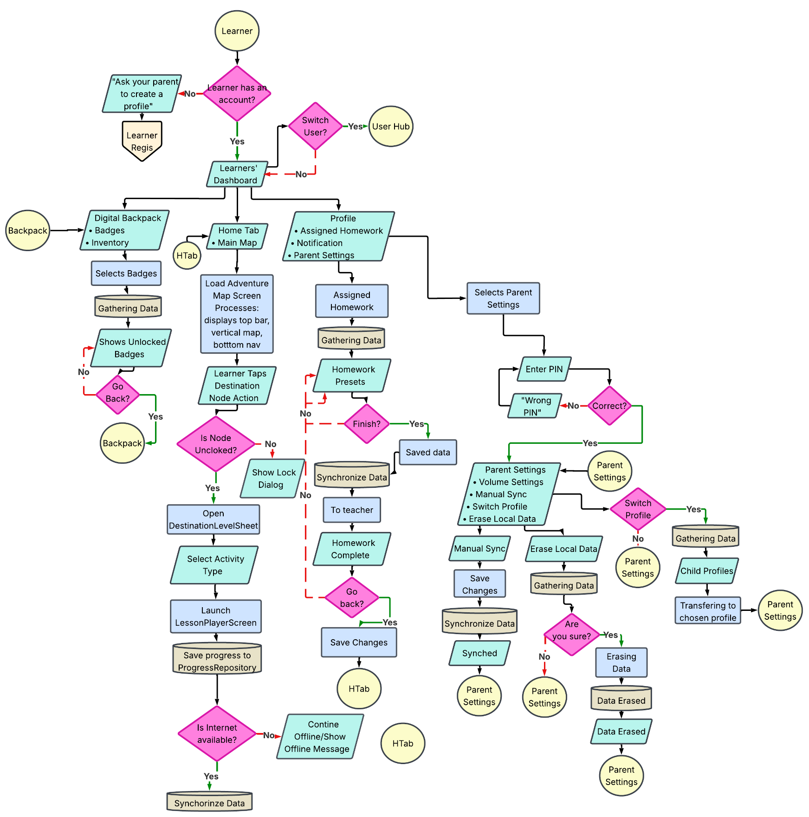

Figure 6 illustrates how learners will move in SalamLearn. It begins with account verification and access to Learner Dashboard, where learners can access Digital Backpack, Adventure Map, assigned homework, and profile settings. This also shows how learners can unlock destinations, launch lessons, save their progress and select activities. You can refer to appendix E to further understand how Learner profile can be created.
Figure 7
SalamLearn Parent Flowchart
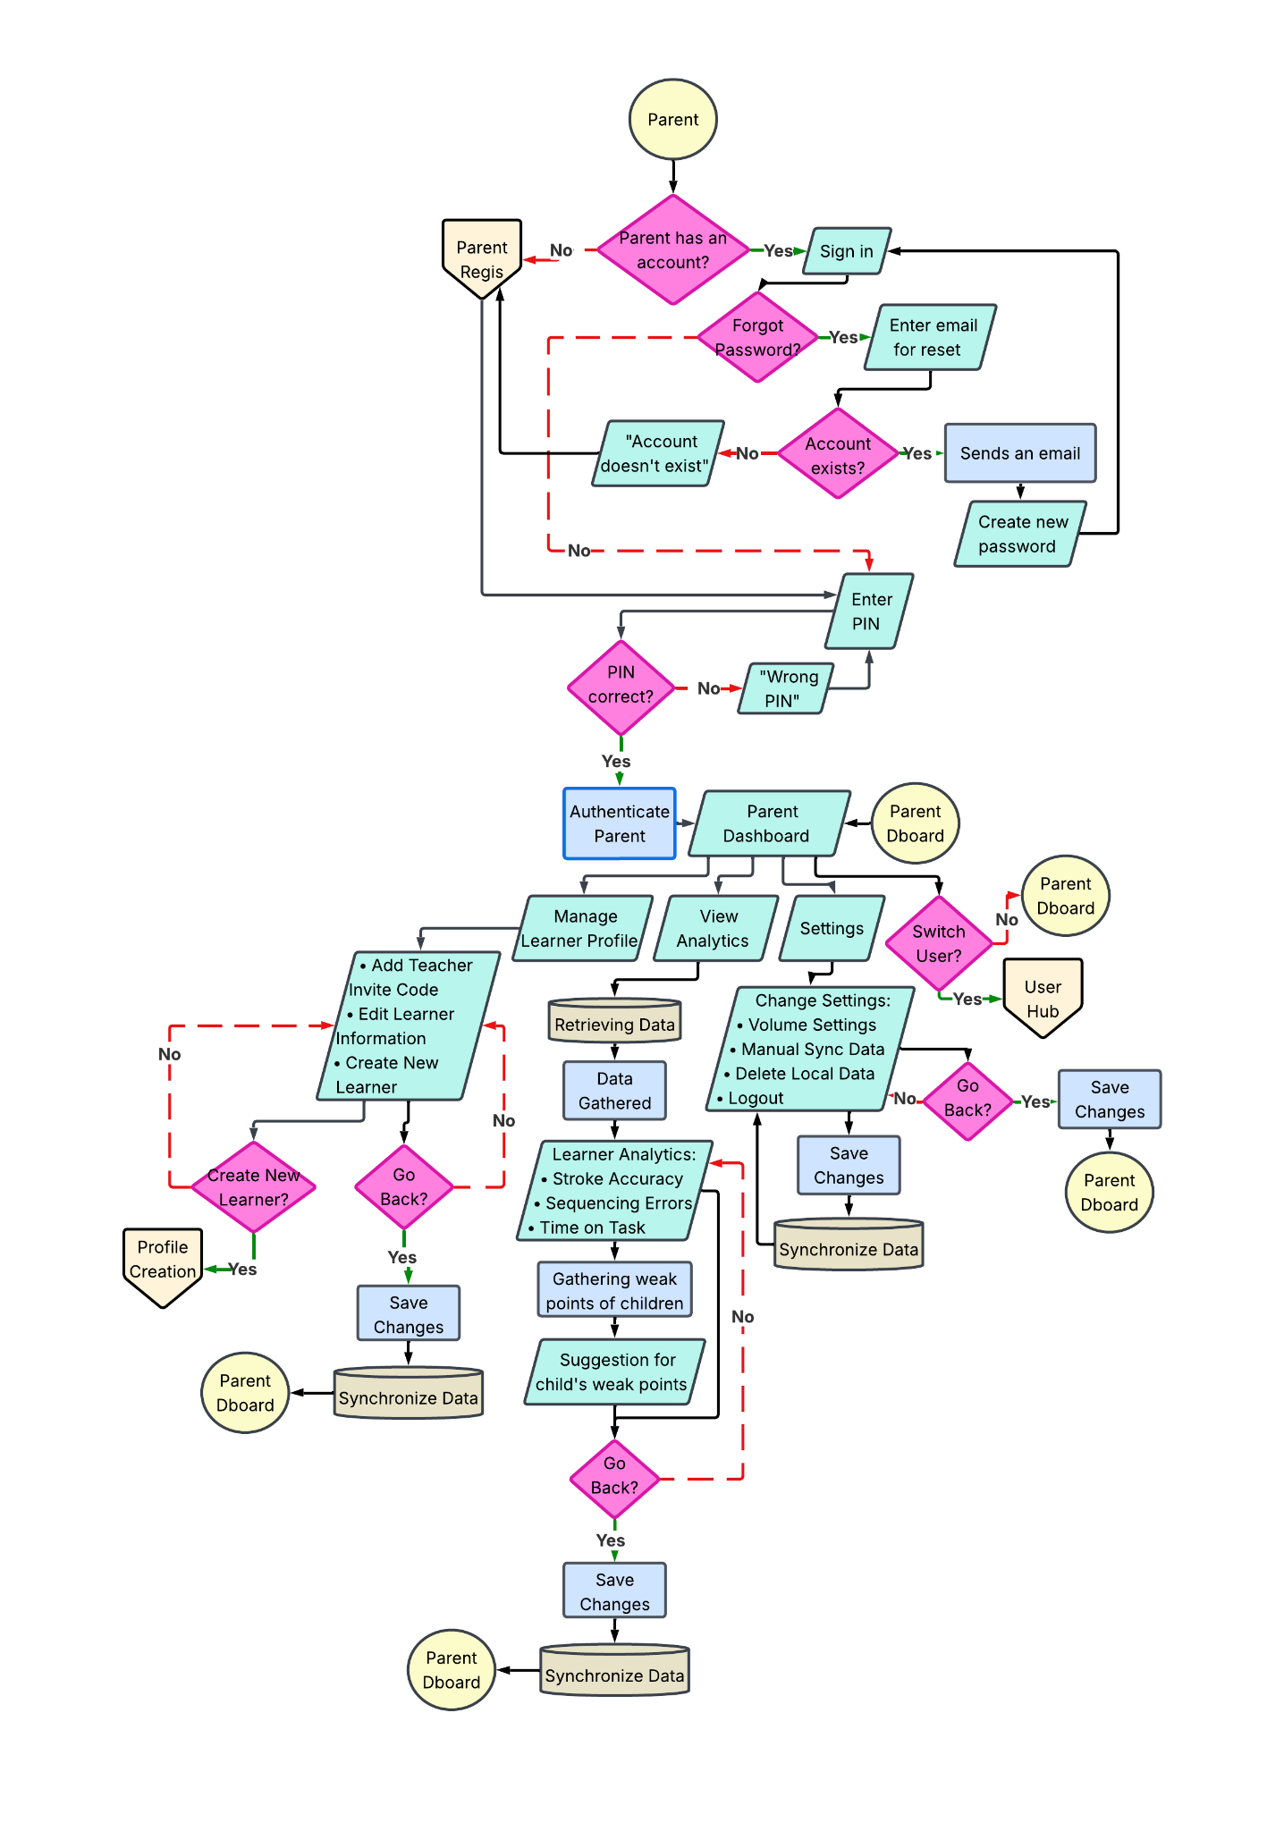
Figure 7 illustrates how parents will move in SalamLearn. From account registration to authentication process, including PIN verification. After that, parents can manage their child’s profiles, create new learner accounts for their child, view learner analytics, customize settings, synchronize data, and switch between learner profiles if available. You can refer to appendix C to further understand how parents can create their account.

Figure 8
SalamLearn Teacher Flowchart
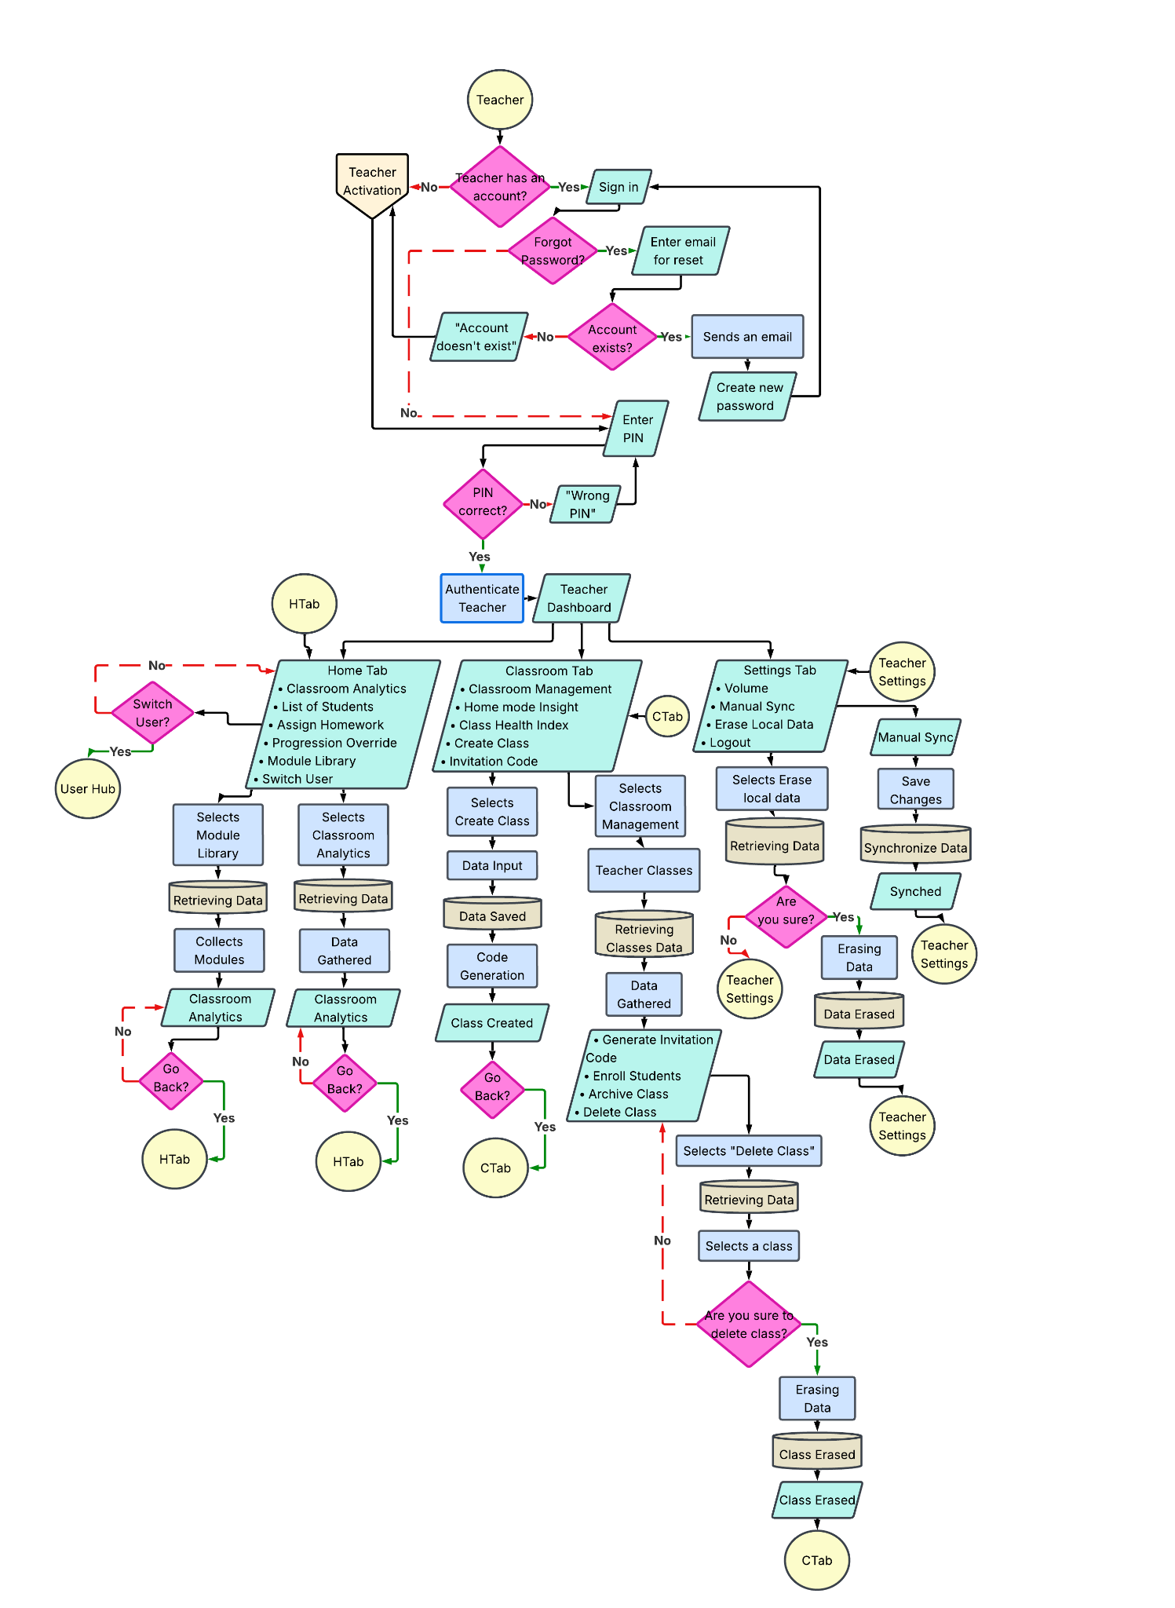
Figure 8 illustrates how Asatidz or teachers will move in SalamLearn. After successful authentication, it proceeds to the Teacher Dashboard, which has the classroom management, student list, homework assigning, classroom analytics, module libraries, and settings. You can refer to appendix D to further understand how the teacher activation works.

Figure 9
SalamLearn Administrator flowchart
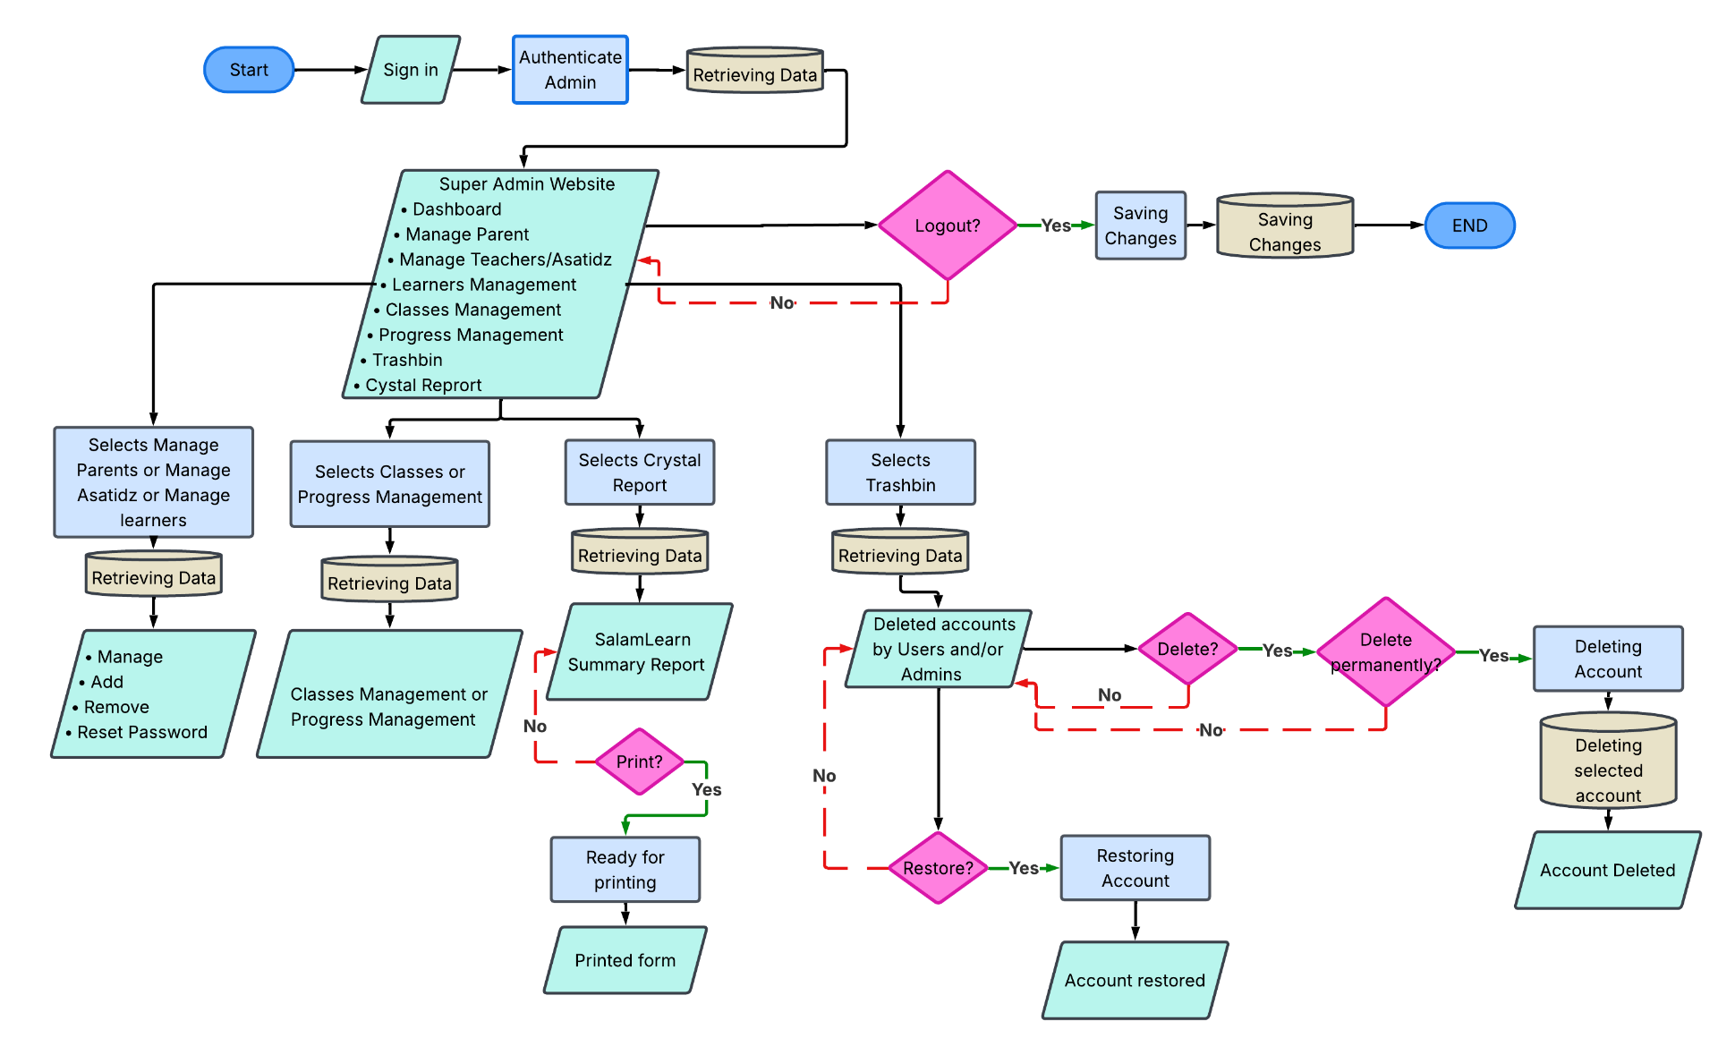
Figure 9 illustrates how the Administrator will move in SalamLearn. Afer authentication, administrators have access to the Super Admin Website to manage parents, teachers or Asatidz, learners, classes, progress, system reports, and trashbin records. It includes the process of retrieving and managing account data, generation and printing of summary reports, and restoring or permanently deleting the selected accounts from the application.

Use Case Diagram

Figure 10
SalamLearn Use-Case Diagram
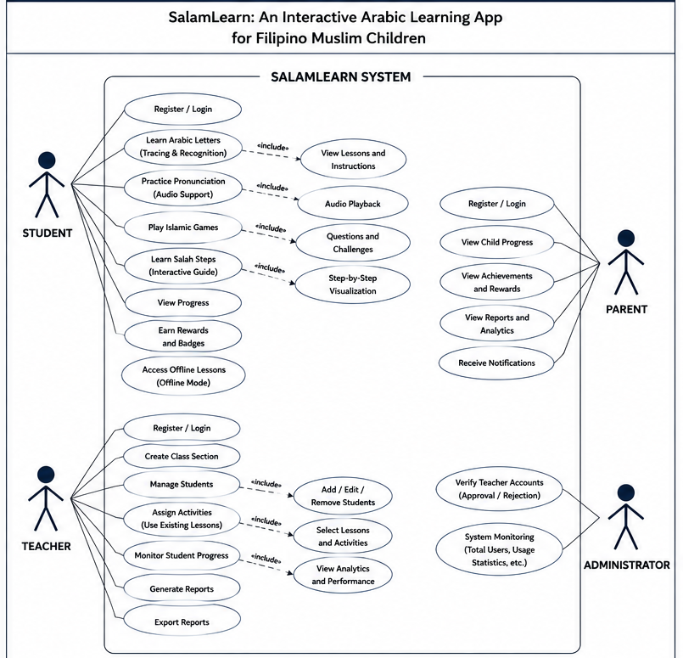

Figure 10 shows the use case diagram of SalamLearn, which illustrates how the system interacts with its four main actors: Student, Parent, Teacher, and Administrator. Each actor has a different set of functions based on their role in the app. The sections below explain these functions for each actor in detail.
Student
The student is the primary user of SalamLearn, referring to Filipino Muslim children who use the app to learn Arabic and basic Islamic practices. After logging in, the student gains access to the various learning modules built into the system. The Learn Arabic Letters feature teaches path tracing and recognition through guided lessons, while the Practice Pronunciation feature uses audio playback to help the child develop correct pronunciation of Arabic sounds. The Play Islamic Games module turns learning into an activity by presenting questions and challenges in a game-based format. Salah, or the Muslim prayer, is taught through the Learn Salah Steps feature, which breaks the process down into a step-by-step visual guide. Outside of these lessons, the student can check their own learning progress, collect rewards and badges as they complete activities, and continue studying even without internet access through the app's offline mode.
Parent
The parent acts as a supervisor for the Student, using a separate account to keep track of the child's learning without directly accessing the lesson content itself. Once logged in, the parent can view the child's progress within the app, including which lessons have been completed and how the child is performing overall. The app also lets the parent see any achievements and rewards the child has earned, giving them a way to recognize the child's effort. For a more complete picture, the parent can check reports and analytics that summarize the child's learning activity over time. The system also sends notifications to the parent, keeping them updated on their child's progress and encouraging continued involvement in the child's learning at home.
Teacher
The teacher manages classroom activities within SalamLearn and oversees student performance. After logging in, the Teacher can create a class section to organize students under their supervision. From there, they can manage their class list by adding, editing, or removing students as needed. The teacher also assigns activities to students by selecting from lessons already available in the system, rather than creating new content from scratch. To keep track of how students are doing, the teacher can monitor student progress and review analytics showing performance across the class or individual students.
Administrator
The administrator oversees the SalamLearn system as a whole, focusing on account management and platform stability rather than the learning content itself. One of their main responsibilities is creating teachers accounts to make sure only legitimate educators can access instructional tools. The administrator also monitors the system, keeping track of total users and usage statistics to make sure the platform is running properly. Through these tasks, the administrator helps keep SalamLearn secure and functional for everyone else using the app, including students, parents, and teachers.

Context Diagram
Figure 11
SalamLearn Context Diagram
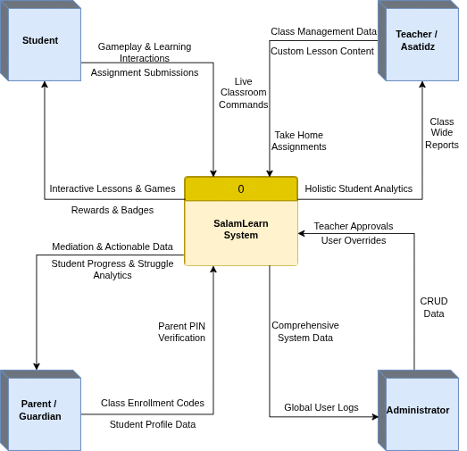

Figure 11 shows SalamLearn as a system that interacts with four external entities: Students, Parents, Teachers, and Administrators. Students use the application to access Arabic learning modules, complete activities, and monitor their learning progress. Teachers manage classes, assign lessons, and monitor student performance. Parents can view their child’s academic progress, achievements to support their learning outside of the classroom. Administrators oversee user management.

Data Flow Diagram
Figure 12
SalamLearn Data Flow Diagram (Level 1)
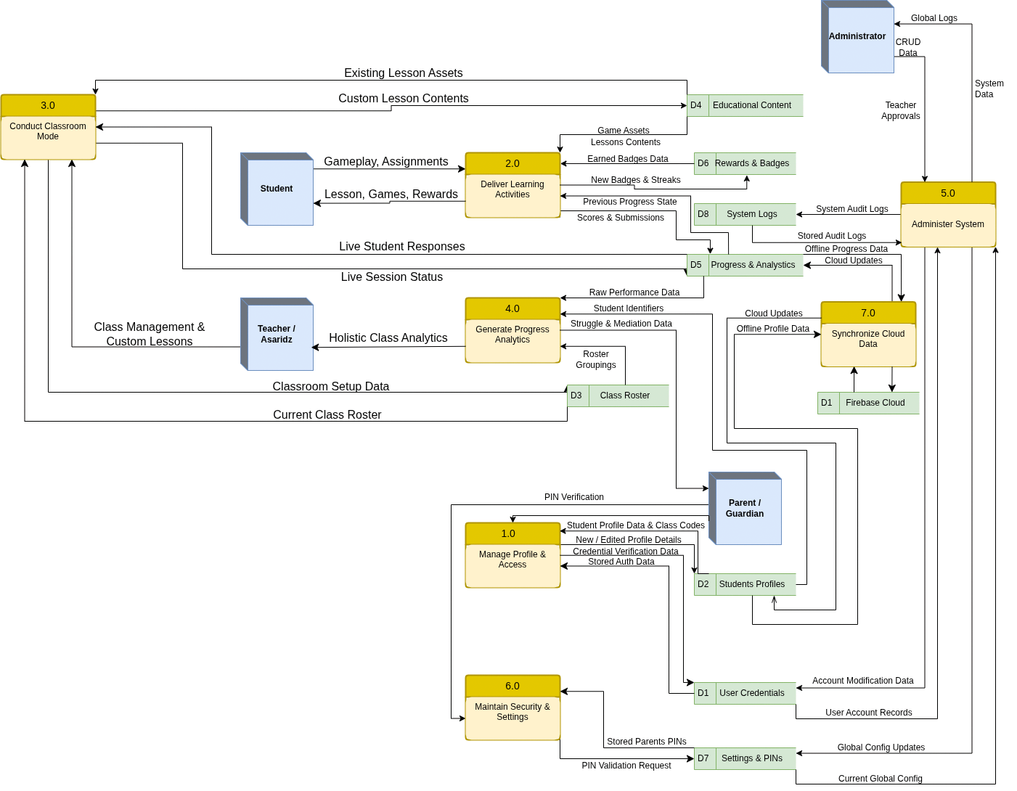
Figure 12 illustrates the Level 1 Data Flow Diagram (Diagram 0), which expands the SalamLearn system into seven major interconnected processes. Process 1.0 (Manage Profiles & Access) handles authentication and allows Parents to create Student profiles and input class enrollment codes. Process 2.0 (Deliver Learning Activities) serves as the core student interface, delivering game assets, recording scores, and distributing badges. Process 3.0 (Conduct Classroom Mode) enables Teachers to set up classrooms, deploy custom lessons, and manage live sessions. Process 4.0 (Generate Progress Analytics) aggregates raw performance data to provide holistic class reports for Teachers and specialized struggle-mediation insights for Parents. Administrative tasks are handled in Process 5.0 (Administer System), where Admins oversee global logs and account modifications. Process 6.0 (Maintain Security & Settings) specifically manages Parent PIN validations to secure restricted features. Finally, Process 7.0 (Synchronize Cloud Data) ensures all local, offline progress and profile data are securely backed up and synced with the central Firebase Cloud database.

System Development Process

The development of SalamLearn will be developed on a modern, scalable technical stack, organized into front-end, offline data, and cloud synchronization layers:
- Frontend Environment: build using the Flutter framework and the Dart programming language, compiled Ahead-of-Time (AOT) to deliver smooth rendering for the character-tracing and animation modules, even on lower-tier Android phone
- Offline Data Layer: utilizes Hive, a lightweight NoSQL key-value local database built for Dart, to store lessons, learner profiles, and progress logs directly on the device, so the app keeps working with no internet connection.
- Cloud Synchronization: integrates Firebase Authentication for secure user authentication, Cloud Firestore for cloud database management, and Firebase Storage for multimedia resources. These services synchronize learner progress and application data whenever an internet connection becomes available.
- Hardware Requirements: SalamLearn requires an Android device with at least a Quad-Core 1.8 GHz processor, 3 GB of available RAM, 500 MB of available storage, and Android 8.0 (Oreo) or later to run the tracing and audio modules smoothly, the offline classroom mode additionally requires a screen-mirroring-capable device to connect to a projector or television. A stable internet connection is required for account registration, cloud synchronization, and downloading application updates, while the learning modules remain accessible offline through local storage.
- Development Tools: Visual Studio Code (VS Code) as the primary integrated development environment (IDE), with GitHub for version control and source code management among the team members.

Figure 13
System Architecture Diagram

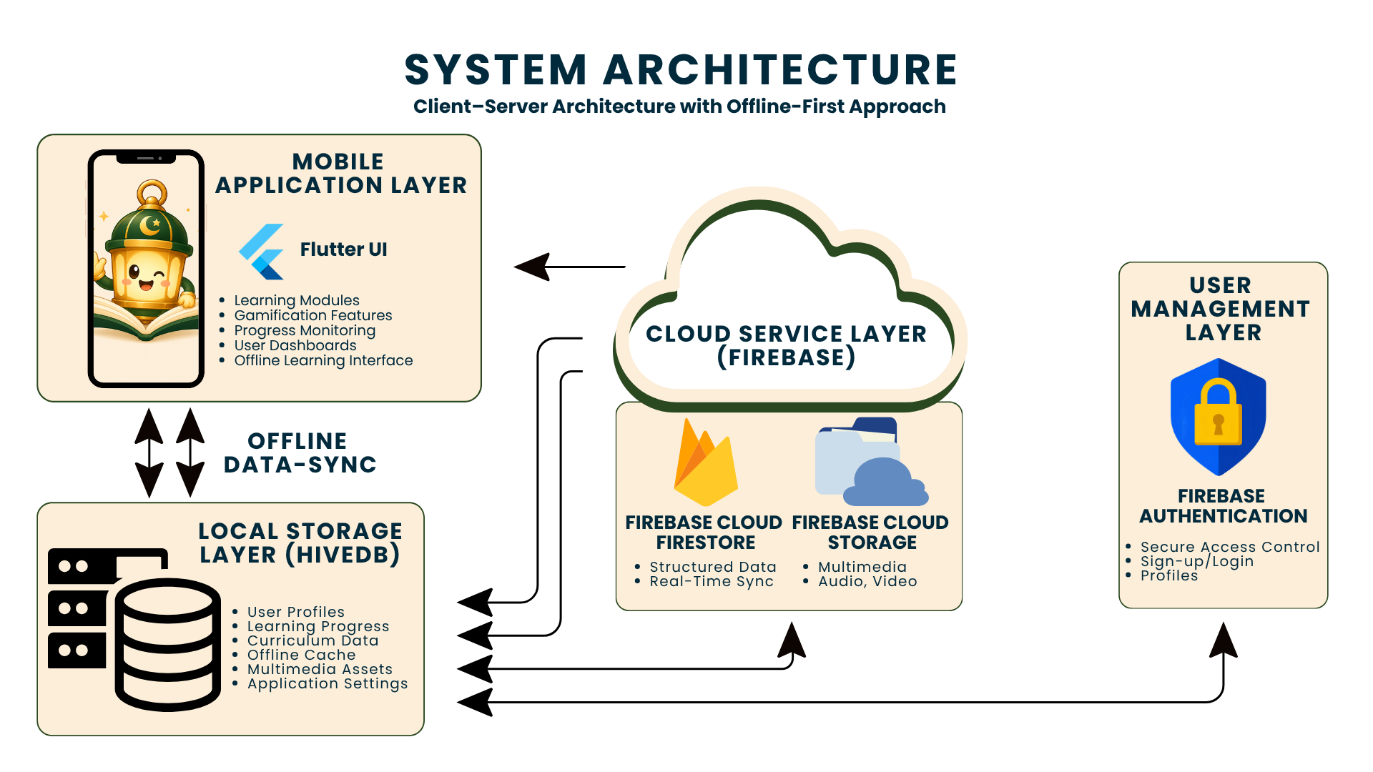
Figure 13 illustrates the system architecture of SalamLearn, which follows a client–server architecture with an offline-first approach. The architecture consists of four primary components: the Mobile Application Layer, Local Storage Layer, Cloud Service Layer, and User Management Layer. The mobile application, developed using Flutter and Dart, provides the learning modules, gamification features, progress monitoring, and user dashboards. The Hive local database stores user profiles, learning progress, curriculum data, and multimedia assets to support offline learning. When an internet connection is available, the application synchronizes local data with Firebase, which provides cloud services such as Cloud Firestore, Cloud Storage, and Firebase Authentication for secure user management, data synchronization, and multimedia storage. This architecture enables SalamLearn to provide continuous and reliable learning experiences both online and offline.

Testing Procedure

To ensure the quality, reliability, and functionality of SalamLearn, the application will undergo unit testing, integration testing, system testing, and user acceptance testing (UAT). Unit testing will verify that individual modules, such as user authentication, learning modules, progress tracking, and offline synchronization, function correctly. Integration testing will verify that the application communicates properly with Firebase services and local Hive storage, while system testing will ensure that all integrated components operate according to the specified functional and non-functional requirements. User acceptance testing will be conducted with the selected participants identified in Section 3.3 to determine whether the application meets their needs and expectations.

The following procedures will be observed during the testing phase:

Researchers will coordinate with participating Madrasah teachers and parents to schedule the testing activities.

Before testing, the researchers will explain the objectives of the study, demonstrate the major features of SalamLearn, and provide instructions on how to use the application.

The participants will be given sufficient time to explore the application's features and perform the assigned tasks using SalamLearn.

Using the prepared functionality, usability, reliability, compatibility test instruments, the participants will verify whether each feature performs according to its expected output and record the results as Passed or Failed.

The researchers will document all identified issues, implement the necessary corrections, and retest the affected modules until the expected results are achieved.

A test case will be considered Passed if the actual output matches the expected output and the feature performs without errors. Otherwise, the test case will be marked Failed and will undergo debugging and retesting before implementation.

Evaluation Procedure

The evaluation of SalamLearn will be conducted under controlled conditions to assess its educational effectiveness and software quality. The procedure will be carried out as follows:

Orientation and Pre-test: The researchers will orient the participants on the objectives of the study and demonstrate the major features of SalamLearn. Selected Grade 1 to Grade 3 learners will then complete a pre-test to determine their baseline knowledge of the selected Arabic and Islamic lessons.

Application Implementation: The learners will use SalamLearn during the designated implementation period under the guidance of their parents and Madrasah teachers. During this period, participants will explore the application's learning modules, interactive activities, and assessment features.

Post-test and System Evaluation: At the end of the implementation period, the learners will complete a post-test to measure their learning improvement. Madrasah teachers and parents will then evaluate the application using a researcher-developed evaluation questionnaire based on the ISO/IEC 25010 Software Quality Model.

Data Collection: The completed questionnaires and assessment results will be collected and organized for statistical analysis. To ensure unbiased responses, participants will complete the evaluation independently, and all collected data will be treated with confidentiality.

Implementation Plan

The implementation of SalamLearn will follow a parallel changeover strategy, allowing the application to be introduced alongside the existing Madrasah teaching methods before becoming part of regular classroom activities. This approach minimizes disruptions and allows teachers and learners to gradually adapt to the new learning platform.
Figure 14
SalamLearn Proposed Implementation Plan

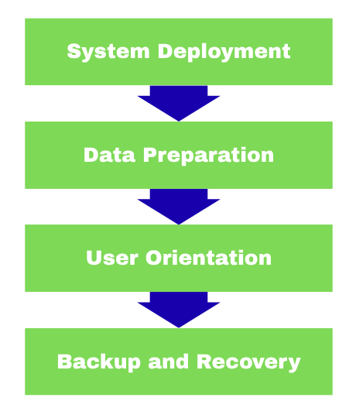

System Deployment: SalamLearn will be deployed using Firebase cloud services, enabling secure user authentication, cloud database management, and multimedia storage. The application will be distributed to participating learners, parents, and Madrasah teachers through Android installation packages (APK).

Data Preparation: User accounts, learner profiles, and learning records will be created and organized prior to implementation. The application will synchronize user data with Cloud Firestore whenever an internet connection becomes available, while Hive will maintain local copies for offline access.

User Orientation: The researchers will conduct an orientation for participating teachers and parents on the installation, features, and proper use of SalamLearn. A user manual will also be provided to assist users during implementation.

Backup and Recovery: To prevent data loss, learner records and application data will be regularly synchronized with Firebase cloud services. Hive local storage will retain offline data until synchronization is completed after connectivity is restored.

Ethical Considerations

The study will be conducted in accordance with ethical research principles and the provisions of Republic Act No. 10173, otherwise known as the Data Privacy Act of 2012. Prior to the implementation and evaluation of SalamLearn, an Informed Consent Form will be provided to all participating parents and Madrasah teachers, explaining the objectives of the study, the voluntary nature of participation, and their right to withdraw at any time without penalty. Since the study involves elementary learners, parental or guardian consent will be obtained before their participation.

To ensure confidentiality, all information collected during the study will be used solely for academic and research purposes. Participant identities will remain anonymous in all reports, and only the researchers and the research adviser will have access to the collected data. SalamLearn will utilize Firebase Authentication for secure account management, while user data will be stored and synchronized through Firebase services with access restricted according to user roles.

All completed questionnaires, assessment results, and research records will be securely stored in password-protected digital storage throughout the study. After the required institutional retention period, all research records containing identifiable participant information will be securely deleted or disposed of in accordance with institutional policies and applicable data privacy regulations.

REFERENCES

Abrenica, J. T. (2021). Lived experiences, academic performance, and aspirations of a Muslim learner in a public high school. International Journal of Scientific Research and Management, 9(12), 2019-2027. https://doi.org/10.18535/ijsrm/v9i12.el01
Aguilera, C. A., Castro, A., Scheihing, E., Medina Paredes, J., & Aguilera, C. (2026). Offline technology for rural AI literacy: Steps towards a holistic educational solution. Sustainability, 18(10), 5105. https://doi.org/10.3390/su18105105
Aguilos, V., & Fuchs, K. (2022b). The Perceived Usefulness of Gamified E-Learning: A study of Undergraduate students with implications for Higher education. Frontiers in Education, 7. https://doi.org/10.3389/feduc.2022.945536
Almelhes, S. A. (2024b). Gamification for teaching the Arabic language to non-native speakers: a systematic literature review. Frontiers in Education, 9. https://doi.org/10.3389/feduc.2024.1371955
Alsadoon, E., Alkhawajah, A., & Suhaim, A. B. (2022b). Effects of a gamified learning environment on students’ achievement, motivations, and satisfaction. Heliyon, 8(8), e10249. https://doi.org/10.1016/j.heliyon.2022.e10249
Attarwiyah, N. M., Wasi'ah, I. R., & Jennah, S. N. (2025). Bridging tradition and technology: Gamification in modern Islamic boarding schools. Journal of Social Studies and Education, 3(1), 28-41. https://doi.org/10.61987/jsse.v3i1.668
Azis, M. & Winata, Koko Adya & Nurishlah, Laesti & Mashfufah, Syifa & Wilza, Romi. (2025). Gamification in Islamic Religious Education for Primary Students: A Systematic Review on Motivation, Emotional Engagement, and Learning Psychology. Proceeding of the International Conference on Social Sciences and Humanities Innovation. 2. 24-30. 10.70062/icsshi.v2i2.71.
Azzah Khadim Hussain, & Haneen Muhammad Asif. (2025). ANDROID APPS FOR TEACHING CHILDREN ARABIC LANGUAGE AND THEIR EFFECTIVENESS IN DEVELOPING LANGUAGE SKILLS. Journal of Applied Linguistics and TESOL (JALT), 8(4), 48–63. https://doi.org/10.63878/jalt1640
Balah, Khadiguia. (2023). A Systematic Review on the Implementation of the Arabic Language and Islamic Values Education (ALIVE) Program in the Philippines: Implications on the Educational Psychology Practice. International Journal For Multidisciplinary Research. 5. 1-20. 10.36948/ijfmr.2023.v05i06.11290.
Baling, L. R. (2026). Development of mobile application utilizing local history in teaching Araling Panlipunan. International Journal of Education, Research, and Innovation Perspectives, 2(4).
Bansod, D., Bangare, S., & Pawankar, V. (2026). A Robust Offline-First Architecture for Integrated Examination and Institutional Data Management in Rural Educational Societies. IJARCCE, 15(4), 139-145. https://doi.org/10.17148/IJARCCE.2026.154139
Carrión-León, D. I. Lopez-Ramos, M. P., Santillan-Valdiviezo, L. G., Tanguila-Tapuy, D. S., Morocho-Santos, G. M., Moyano-Arias, R. J., Yautibug-Apugllón, M. E., & Chacón-Luna, A. E. (2025). Evaluating interaction capability in a serious game for children with ASD: An operability-based approach aligned with ISO/IEC 25010:2023. Computers, 14(9), 370. https://doi.org/10.3390/computers14090370
Cortez, A. R. Jr. (2026). A madrasah program in the Philippines: Arabic language and Islamic values education (ALIVE) teachers' voices. Issues in Educational Research, 36(2), 438-473. http://www.iier.org.au/iier36/cortez.pdf
Daud, A. Z. C., Aman, N. A., Chien, C. W., & Judd, J. (2020). The effects of touch-screen technology usage on hand skills among preschool children: a case-control study. F1000Research, 9(1306). https://doi.org/10.12688/f1000research.25753.1
Dela Rosa, A. P. M. (2025). Assessing data privacy attitudes of information technology students: Basis for awareness enhancement. Asian Journal of Education and Social Studies, 51(7), 617-627. https://doi.org/10.9734/ajess/2025/v51i72152
Department of Education. (2017). Policy guidelines on Madrasah education in the K to 12 basic education program (DepEd Order No. 41, s. 2017). Department of Education, Republic of the Philippines.
Doce, L. J. P. (2018). RA 10173 and its challenges to Philippine state universities and colleges' compliance performance. Proceedings of the 2018 International Conference on Information System Performance. https://doi.org/10.1145/3234781.3234789
Fatimah, & Pribadi, F. (2025). The digital da'wah (preachers) and hegemony in digital age. Journal of Southern Sociological Studies, 1(2), 206-223. https://doi.org/10.26740/jsss.v1i2.40520
Figueiredo, S. (2023c). The effect of mobile‐assisted learning in real language attainment: A systematic review. Journal of Computer Assisted Learning, 39(4), 1083–1102. https://doi.org/10.1111/jcal.12811
Firdausia, A. S. (2026). Fostering student questioning in Islamic education: The learning starts with a question strategy in a vocational high school. Journal of Islamic Education, 12(2), 145-159. https://doi.org/10.37680/qalamuna.v16i1.4902
GlobeDock Academy. (2023). Bridging the education gap in Ethiopia through AI-powered, offline-first digital learning. UNESCO SDG 4 Knowledge Hub. https://www.unesco.org/sdg4education2030/en/knowledge-hub/bridging-education-gap-ethiopia-ai-powered-offline-digital-learning
Goodall, J., & Flewitt, R. (2025). Parental mediation of very young children's early experiences with digital media at home. Educational Review, 1-26. https://doi.org/10.1080/00131911.2025.2579531
Hatira, A. and Sarac, M. (2024), Touch to Learn: A Review of Haptic Technology's Impact on Skill Development and Enhancing Learning Abilities for Children. Adv. Intell. Syst., 6: 2300731. https://doi.org/10.1002/aisy.202300731
Hejaili, A. A., & Newbury, P. (2023). LAA: Learn the Arabic Alphabet: Integrating Gamification Elements with Touchscreen Based Application to Enhance the Understanding of the Arabic Letters Forms. Electronic Journal of E-Learning, 21(4), 353–365. https://doi.org/10.34190/ejel.21.4.3043
Hussain, A. K., & Asif, H. M. (2025). Android Apps for Teaching Children Arabic Language and Their Effectiveness in Developing Language Skills. Journal of Applied Linguistics and TESOL, 8(4), 48-63. https://doi.org/10.63878/jalt1640
Idhan, M., Jabir, M., Ruslin, Asmawi, M. N., Arafah, B., Ubadah, Ubay, & Fatima. (2026). Teachers' experiences with mobile apps for Arabic language learning: Insights from Islamic schools in Palu, Indonesia. Journal of Language Teaching and Research, 17(1), 338-350. https://doi.org/10.17507/jltr.1701.34
Januhari, N. N. U., Setyanto, A., Kusrini, Utami, E., & Martínez-Béjar, R. (2025). Evaluation of e-learning usability based on ISO 25010 with Hofstede's cultural dimensions as moderation: A PLS-SEM study in higher education. Applied Information System and Management, 8(1), 159-168. https://doi.org/10.15408/aism.v8i1.45738
Jogo, D. A., Challco, G. C., Bittencourt, I. I., Reis, M., Silva, L. R., & Isotani, S. (2022c). Investigating how gamified syllabic literacy impacts learning, flow and inappropriate behaviors: A single-subject study design. International Journal of Child-Computer Interaction, 33, 100458. https://doi.org/10.1016/j.ijcci.2022.100458
Jung, H. S., Lee, H., & Park, K. C. (2025). Analysis of UX elements in educational applications for young children and implementation of ISO/IEC 25010 quality standards. SAGE Open, 15(3). https://doi.org/10.1177/21582440251377385
Kholifia, N. I. K., Basith, A., Nasrulloh, M. A., & Fadly, A. M. H. (2025). Enhancing Arabic Speaking Skills: The Potential of Gamification in Reducing Language Anxiety. Arabiyatuna: Jurnal Bahasa Arab, 9(1), 289–306. https://doi.org/10.29240/jba.v9i1.12217
Lampropoulos, G., & Kinshuk. (2024d). Virtual reality and gamification in education: a systematic review. Educational Technology Research and Development, 72(3), 1691–1785. https://doi.org/10.1007/s11423-024-10351-3
Learning Equality. (2026). Bridging the Gap: Quality Education Through Offline-First Tech. Funds for NGOs. https://news.fundsforngos.org/2026/02/12/bridging-the-gap-quality-education-through-offline-first-tech/
Li, L., Hew, K. F., & Du, J. (2024d). Gamification enhances student intrinsic motivation, perceptions of autonomy and relatedness, but minimal impact on competency: a meta-analysis and systematic review. Educational Technology Research and Development, 72(2), 765–796. https://doi.org/10.1007/s11423-023-10337-7
Liu, X., Ni, C., & Liu, Y. (2023c). Effects of mobile-assisted reading materials on children’s L1 lexical development. Frontiers in Psychology, 14, 1144427. https://doi.org/10.3389/fpsyg.2023.1144427
Mahazari, U. A., & Hamzah, M. I. (2026). Challenges in Implementing Gamification for Teaching and Learning among Islamic Education Pre-Service Teachers: A Systematic Literature Review. International Journal of Academic Research in Progressive Education and Development, 15(2), 1195-1202. https://doi.org/10.6007/IJARPED/v15-i2/21379
Malik, A. A., & Masrur, M. (2025). Qur'anic interpretation of dhikr and the reconfiguration of religious authority in digital media. Indonesian Journal of Islamic Literature and Muslim Society, 10(2), 167-186. https://doi.org/10.22515/islimus.v10i2.13194
Mangadang, A. B., Ubayubay, R. M., & Comon, J. D. (2025). Implementation and Challenges of Arabic Language and Islamic Values Education Program: Basis for School Development Plan. American Journal of Arts and Human Science, 4(1), 129-152. https://doi.org/10.54536/ajahs.v4i1.4139
Mays, T. J., & Cheng, R. Z. (2024). Exploring offline e-learning for resilience: A case study. Journal of Learning for Development, 11(2), 304-310.
Nagy, B., Kutrovátz, K., Király, G., & Rakovics, M. (2023). Parental mediation in the age of mobile technology. Children & Society, 37, 424-451. https://doi.org/10.1111/chso.12599
Nugroho, E. C., & Fx, G. (2025). Evaluating maintainability metrics in microservices-based student registration systems. Software Quality Journal, 12(4), 55-64. https://doi.org/10.367751473
Ochoa, L. F. P., & España, D. J. T. (2026). Mobile app implementation with E-Invoicing to optimize E-Commerce in retail SMEs. Journal of E-Commerce, 1(2), 231-240. https://doi.org/10.369673160
Panda, K. C. (2025). Application development using Flutter and React Native: Cross platform development. Journal of Research in Science and Engineering, 7(1), 6-8. https://doi.org/10.53469/jrse.2025.07(01).02
Pedraza, S. M. M., & Canoy, O. M. (2025). Assessing the effectiveness of mobile learning apps in enhancing student learning and engagement in selected secondary public schools in General Trias City. Psychology and Education: A Multidisciplinary Journal, 45(9), 1170-1181. https://doi.org/10.70838/pemj.450909
Salindab, R. L., & Maglantay, A. A. (2025). Arabic Language and Islamic Values Education (ALIVE) implementation, pedagogical practices of ALIVE teachers and learners' performance. International Journal of Research and Innovation in Social Science, 9(4), 1137-1150. https://dx.doi.org/10.47772/IJRISS.2025.90400087
Samala, A. D., Mubai, A., Jasril, I. R., Ferdian, F., Rawas, S., de Sousa Freitas, D., Monteiro, C., Fikri, R., Hidayat, H., & Al Zaqri, F. (2026). An offline-first collaborative digital logbook application for service-learning programs in low-connectivity regions. SN Computer Science, 7, Article 531. https://doi.org/10.1007/s42979-026-05144-9
Samudio, D. I. (2022). Barriers in front-end web development. 2022 IEEE Symposium on Visual Languages and Human-Centric Computing (VL/HCC). https://doi.org/10.1109/VL/HCC53370.2022.9833127
Soliman, Sommayah & Nathan-Roberts, Dan. (2018). Evaluating Children’s Interaction with Touchscreens From 0 to 8 Years Old. Proceedings of the Human Factors and Ergonomics Society Annual Meeting. 62. 260-264. 10.1177/1541931218621060.
Umar, I., & Argungu, K. A. (2025). Offline capable mobile learning solutions for low connectivity regions. International Journal of Sustainable Social Science, 3(5), 337-354. https://doi.org/10.59890/ijsss.v3i5.107
Yadav, S., & Chakraborty, P. (2018). Smartphone apps can entertain and educate children aged two to six years but should be used with caution. Acta Paediatrica, 107(10), 1834-1835. https://doi.org/10.1111/apa.14435
Zohud, T., & Zein, S. (2021). Cross-platform mobile app development in industry: A multiple case-study. Computing, 20(1), 46-54.
Zulkefli, M., & bin Jamil, A. I. (2024). Advancing Islamic education with game-based learning: Principles, effects, and implementation obstacles. Journal of Islamic Educational Research, 10(1), 1-12. https://doi.org/10.22452/jier.vol10no1.1

APPENDICES
Appendix A
Gantt Chart of SalamLearn
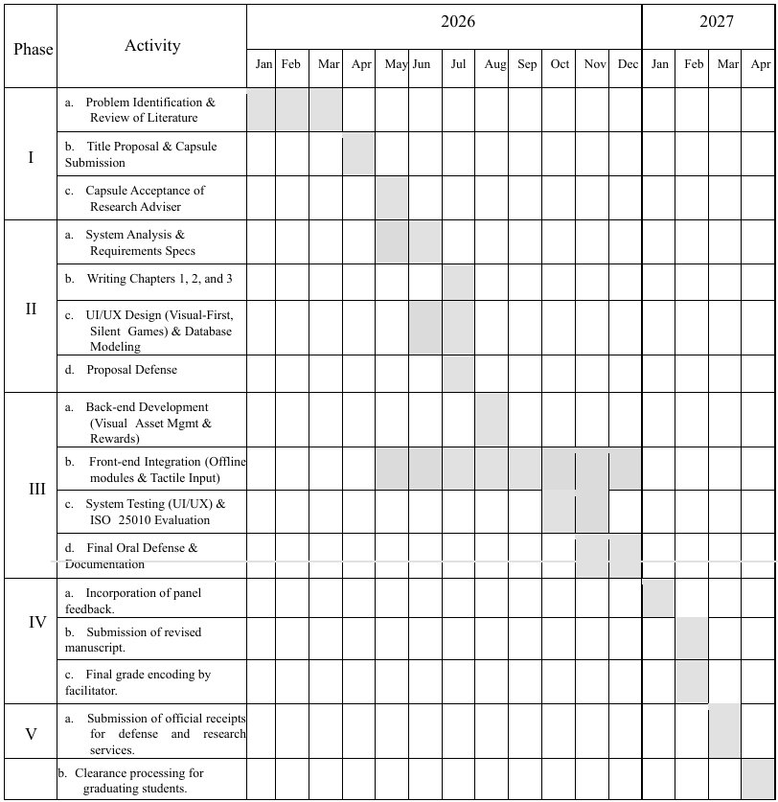

Appendix B
PERT Table of SalamLearn
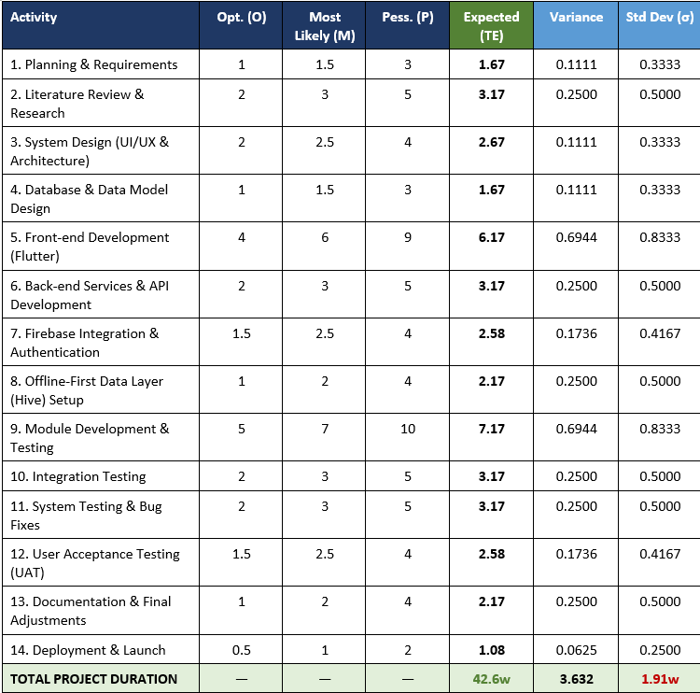

Appendix C
SalamLearn Parent Registration
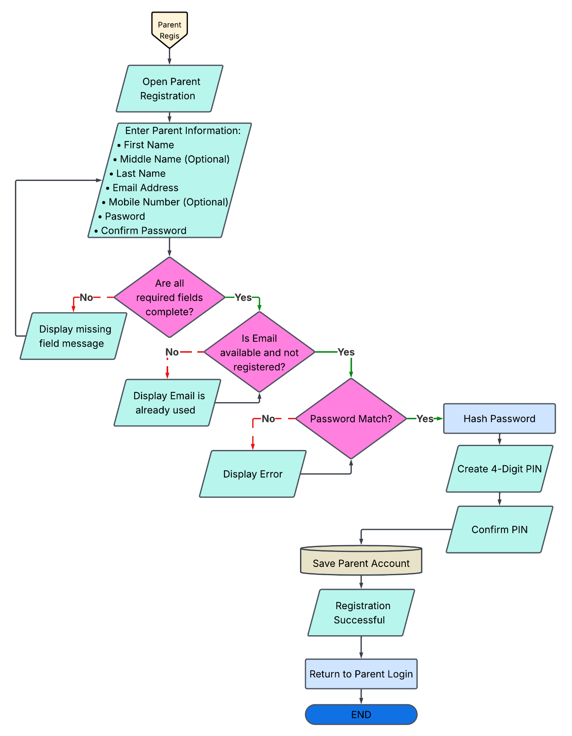

Appendix D
SalamLearn Teacher Activation
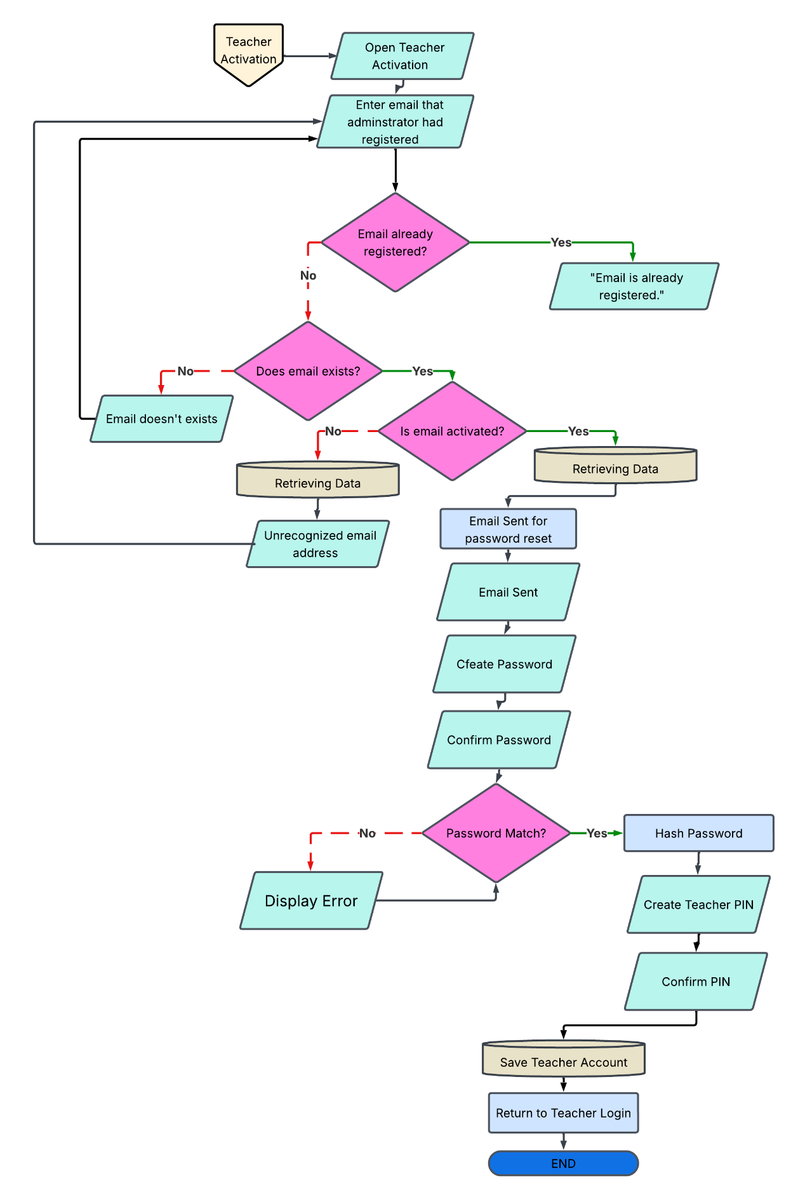

Appendix E
SalamLearn Learner Registration
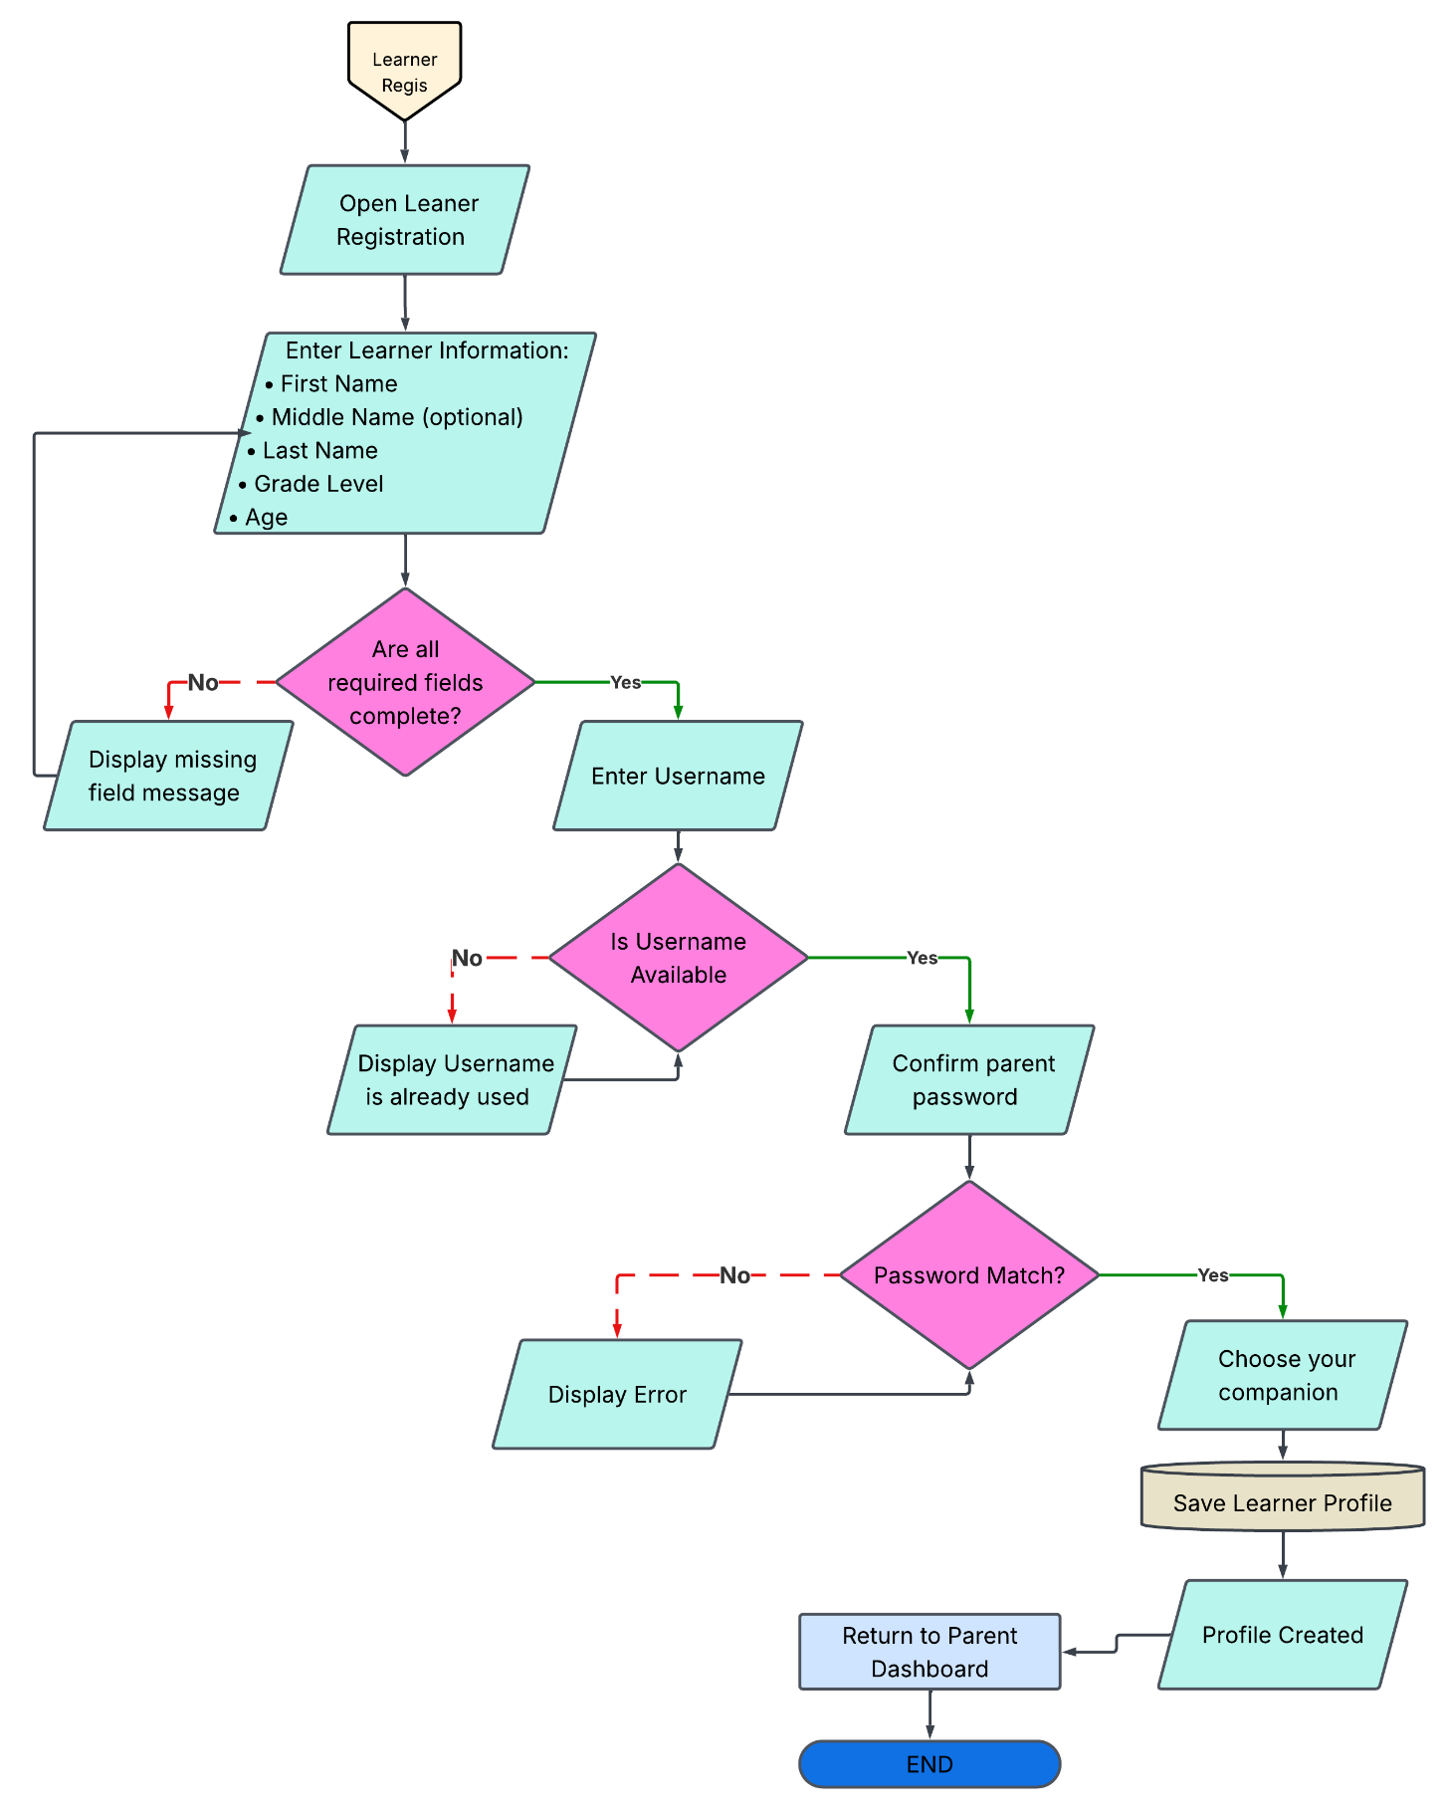

Appendix F
Device Availability Survey
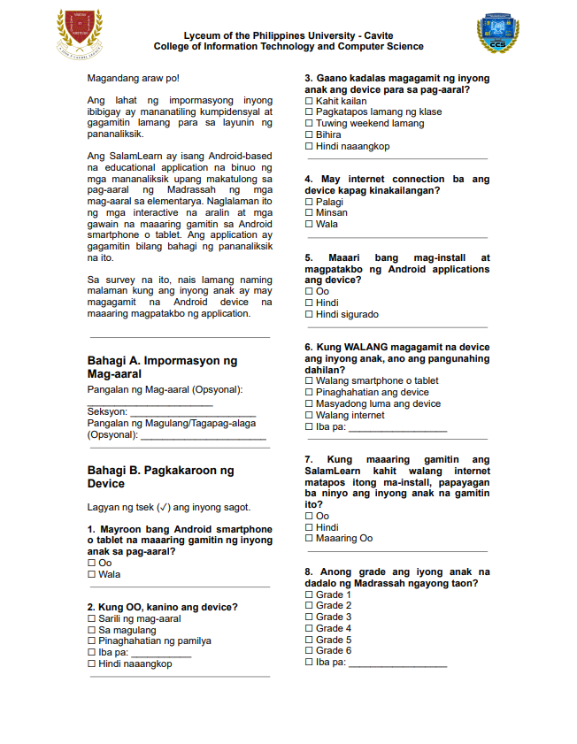

Appendix G
Signing of Approval Letter
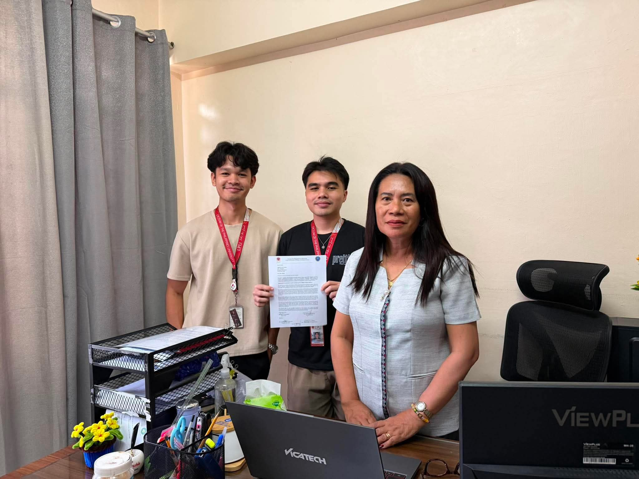

Appendix H
Initial Interview with Content Validators
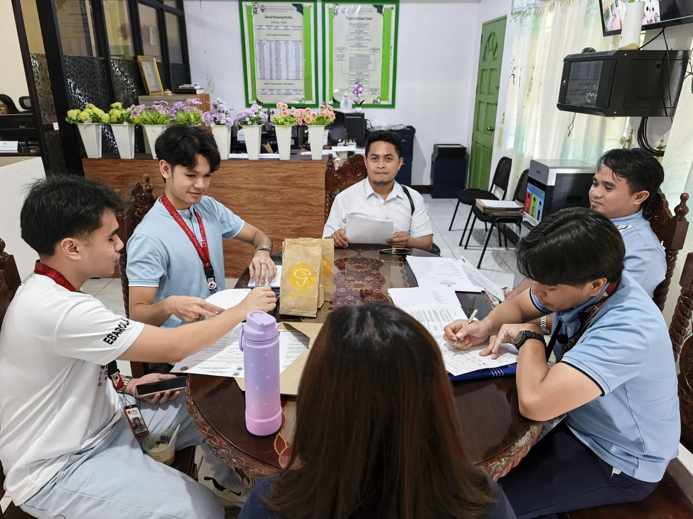

Appendix I
Presentation to DepEd Representative and VAES School Principal
